DEPARTMENT ACTIVITIES OF THE YEAR 2018

FIELD TRIP
PLACE: IICT, TARNAKA DATE: 12/2/2018

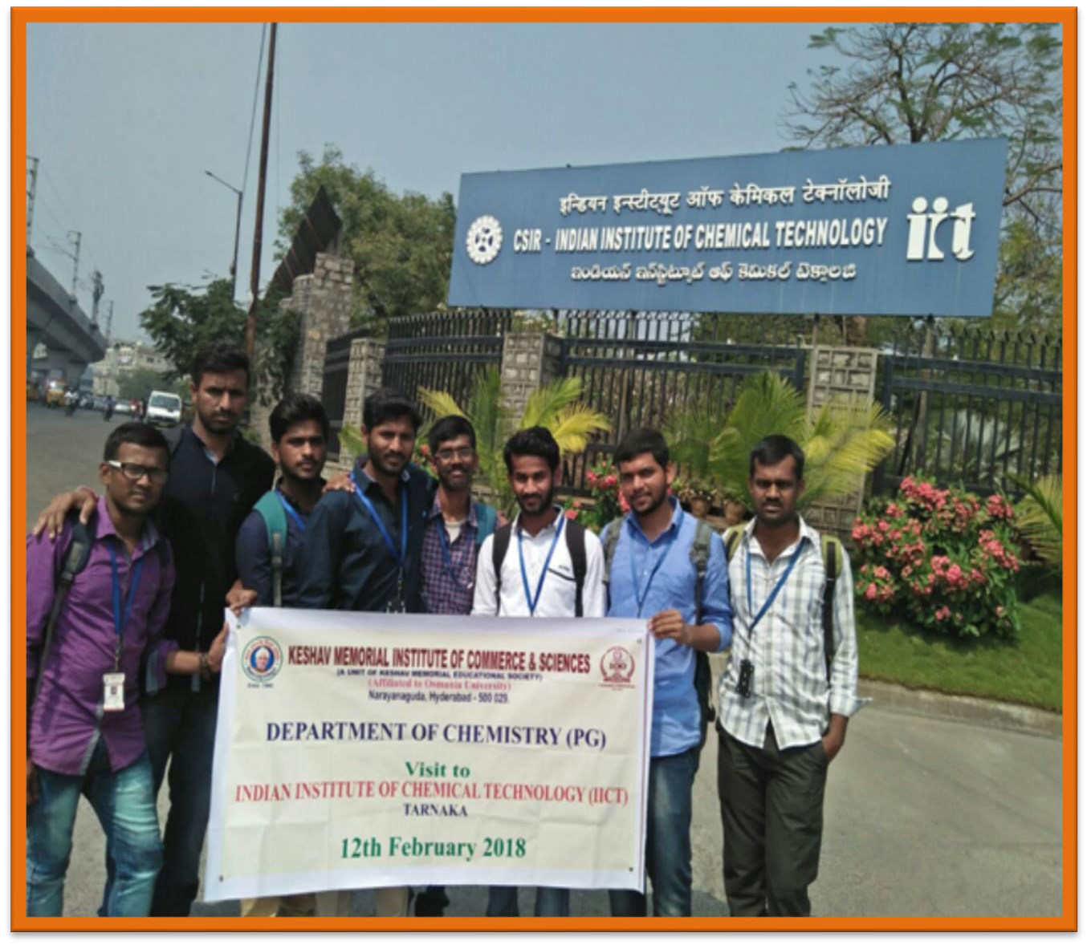

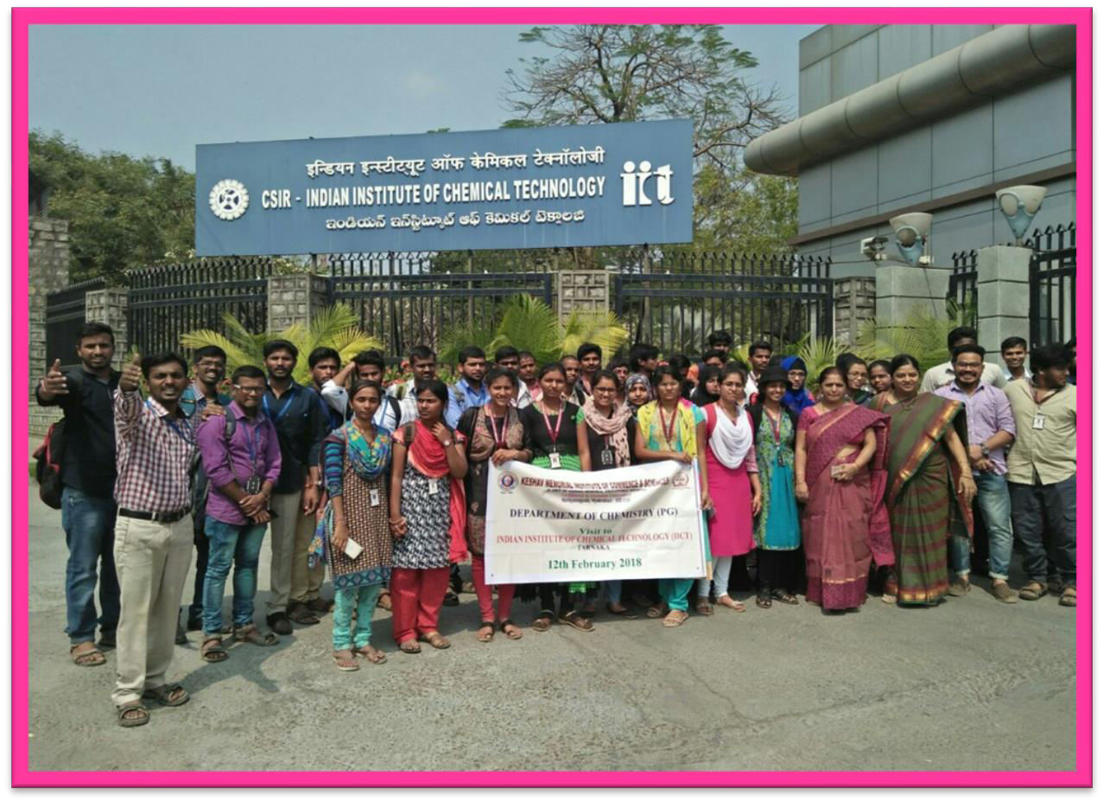

OUTCOME:
PG Chemistry students participated in poster presentation at Indian Institute of Chemical Sciences conducted by the scientists at IICT. They learnt about the instrumentation and principles of working. They got the opportunity to see all the instruments and gained lot of practical knowledge about various techniques used in chemical analysis.

GUEST LECTURE TOPIC – SYMMETRY
RESOURCE PERSON: PROF. CH.SARALA DEVI, BOS, DEPT OF CHEMISTRY, OU. DATE: 11/10/2018
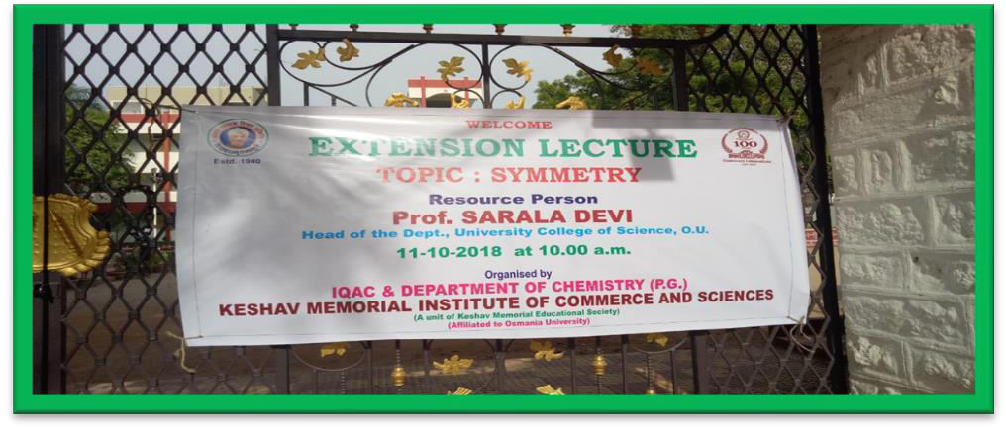
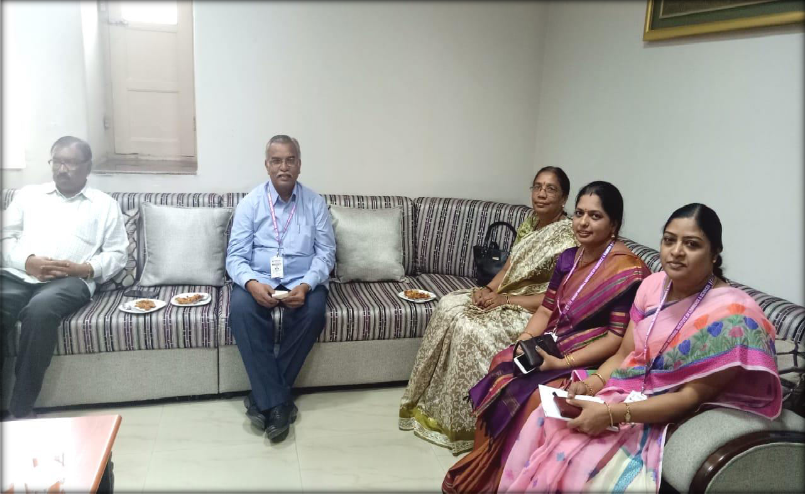

Principal and Faculty Interacting with the Guest speaker

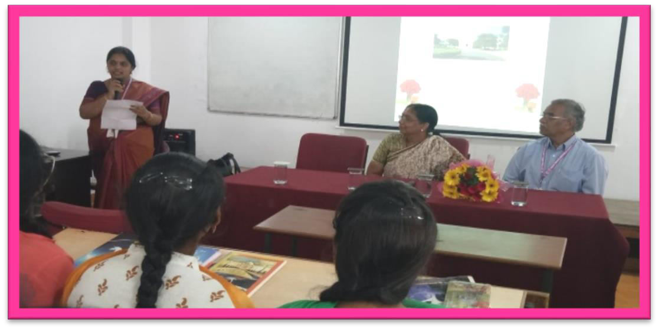
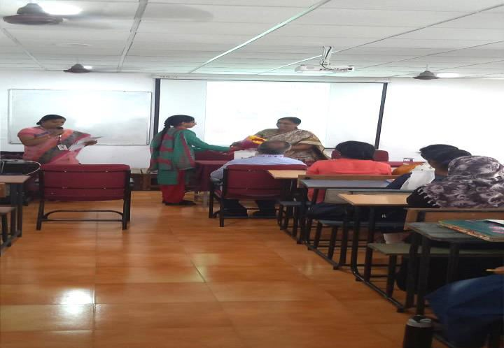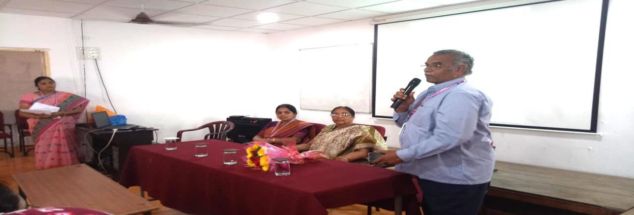

Principal addressing the students

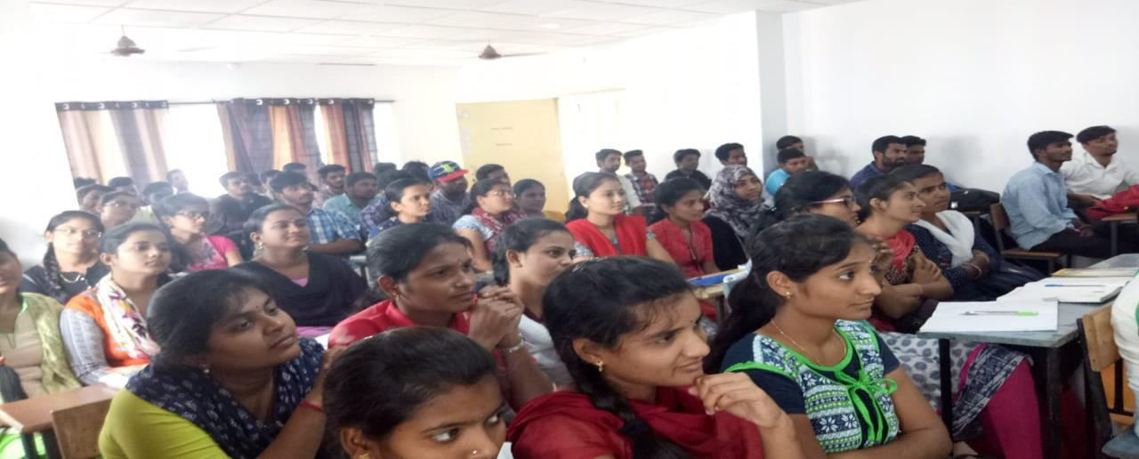
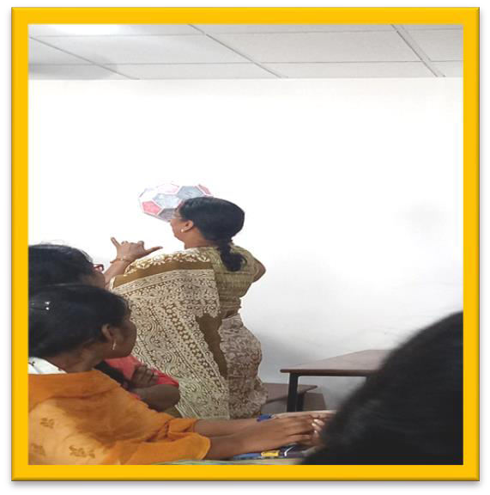

Speaker explaining with model demonstration
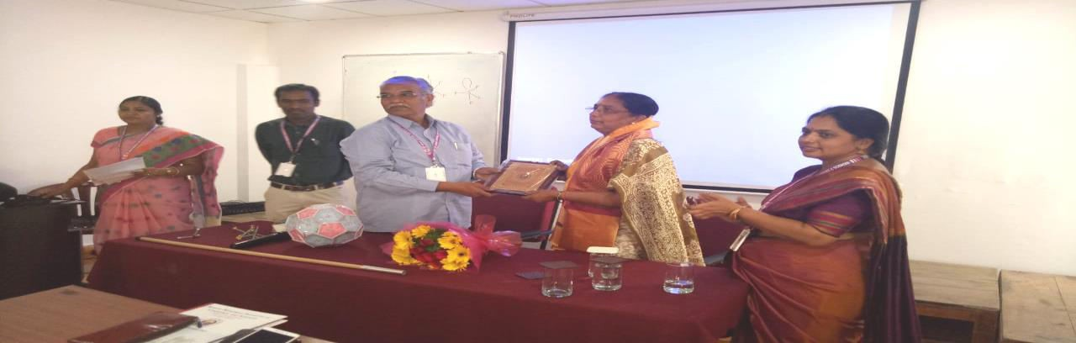
Guest Felicitation

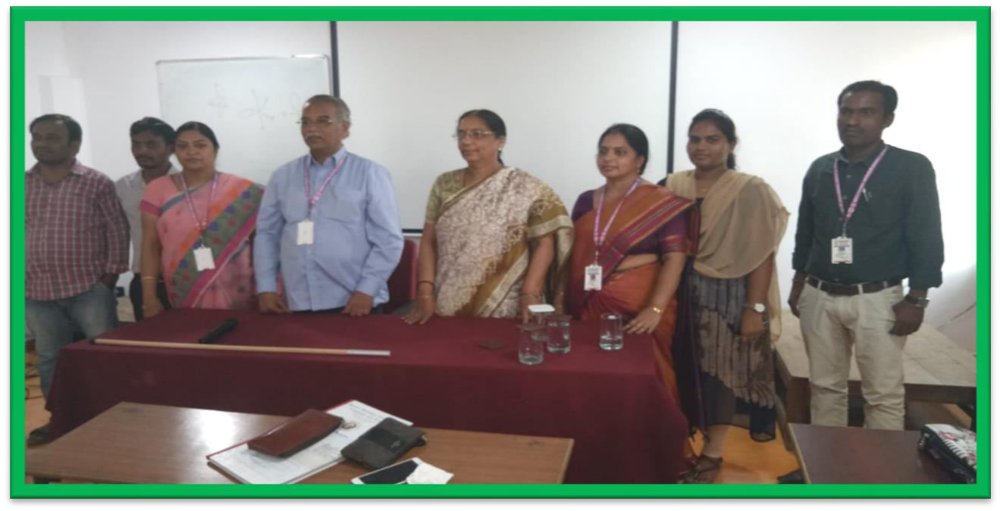

Department faculty with Guest

About:
The Guest speaker explained about the topic symmetry .She has demonstrated various symmetry elements by taking live examples and ball and stick model.

Outcome:
The students understood clearly about the symmetry elements and they could give many examples for different objects which had various symmetry elements. Hence all of them very clearly understood the topic of symmetry

ONE DAY WORKSHOP
RESOURCE PERSON: DR.G. SUDARSAN, HETERO LABS DATE: 9/11/2018

TOPIC: “EMERGING TRENDS AND CHALLENGES IN PHARMACEUTICAL INDUSTRY”.

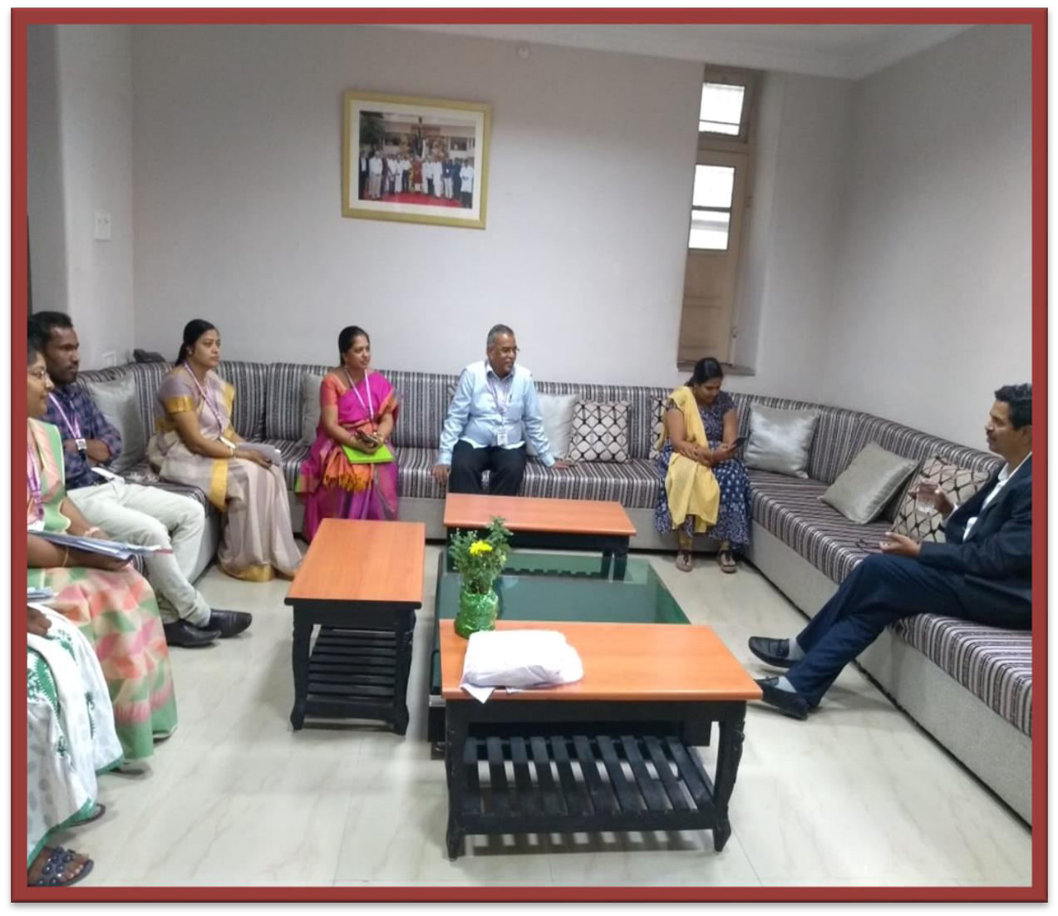
Faculty interacting with Guest with guest

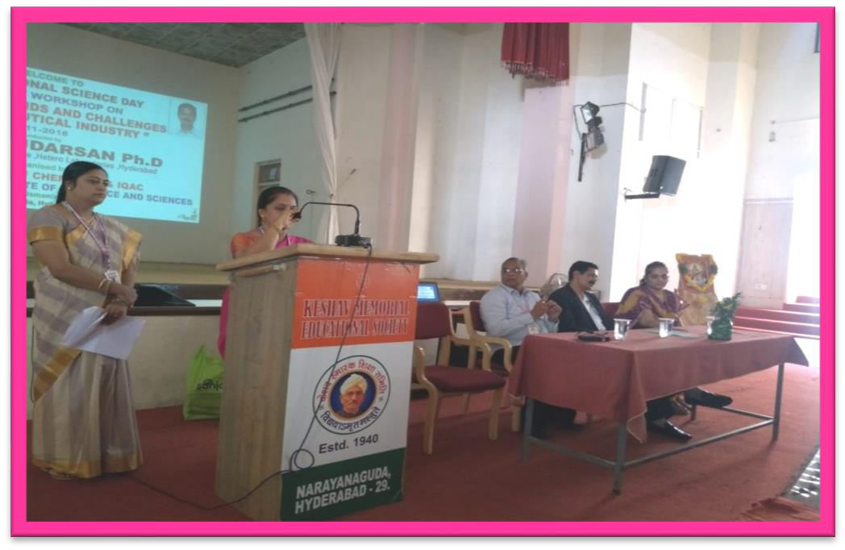

Department report

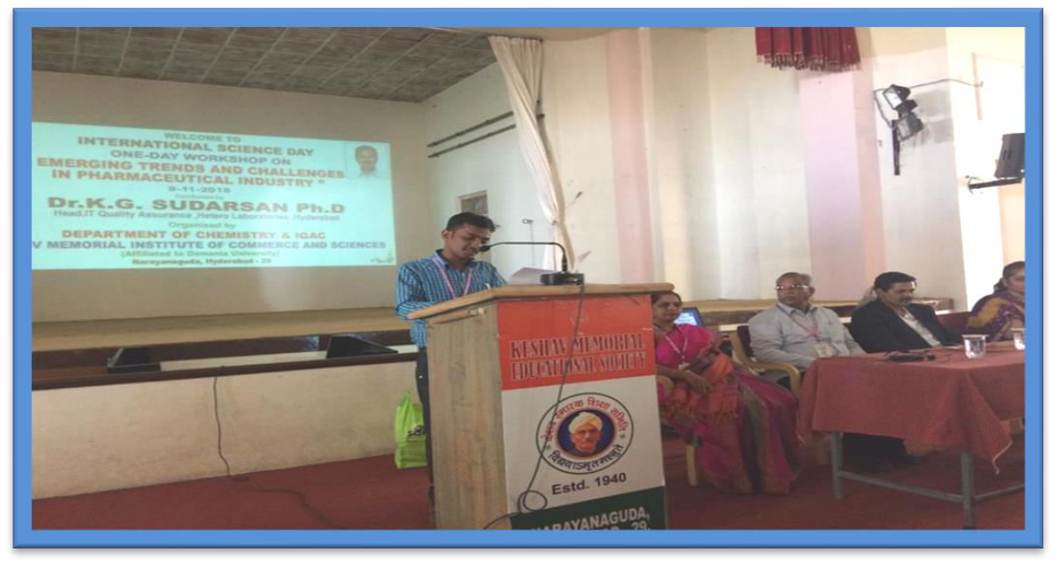
Proposing vote of thanks

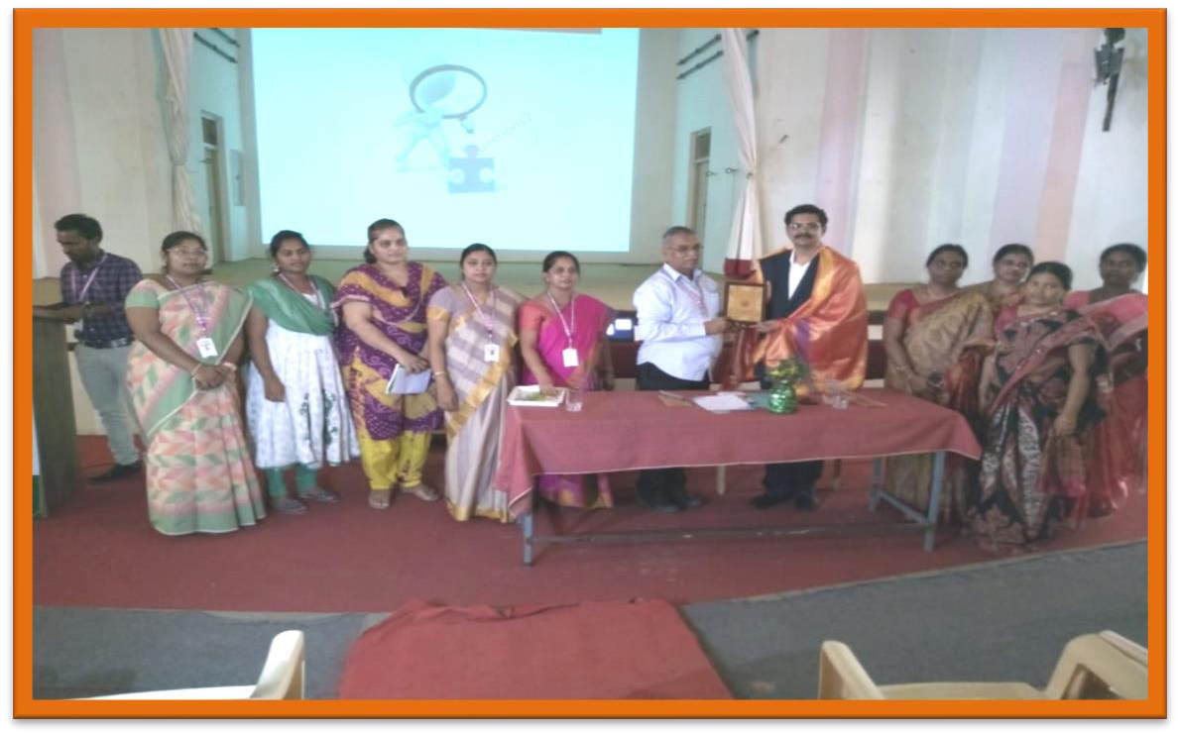

Guest Felicitation

About

One day work shop was conducted in collaboration with Hetero Pharma Lab, around 200 PG Organic and Analytical chemistry students and 15 faculty members from both RBVVR women’s college and KMICS had participated in the workshop organized by Dept of PG Chemistry ,and IQAC of KMICS on account of International science day celebration. Resource person Dr. G. Sudarsan, Head QA and QC in Hetero Pharma has explained clearly about the challenges faced by the pharma industry and also dealt with the new emerging trends in Pharma field. He explained how the academic knowledge is useful in the practical industry; he also said what kind of knowledge the students should gain in order to have good settlement in pharma industry.
Outcome:

It was a good academic and industry collaborative work shop. Students gained practical knowledge regarding industrial work, and what kinds of skills are needed to have good settlement in pharma industry.

NATIONAL SEMINAR
One Day National Seminar was organized by Department of Chemistry P.G on 17th November 2018 on the topic “NEW EXCITING FRONTIERS OF CHEMICAL SCIENCES”.
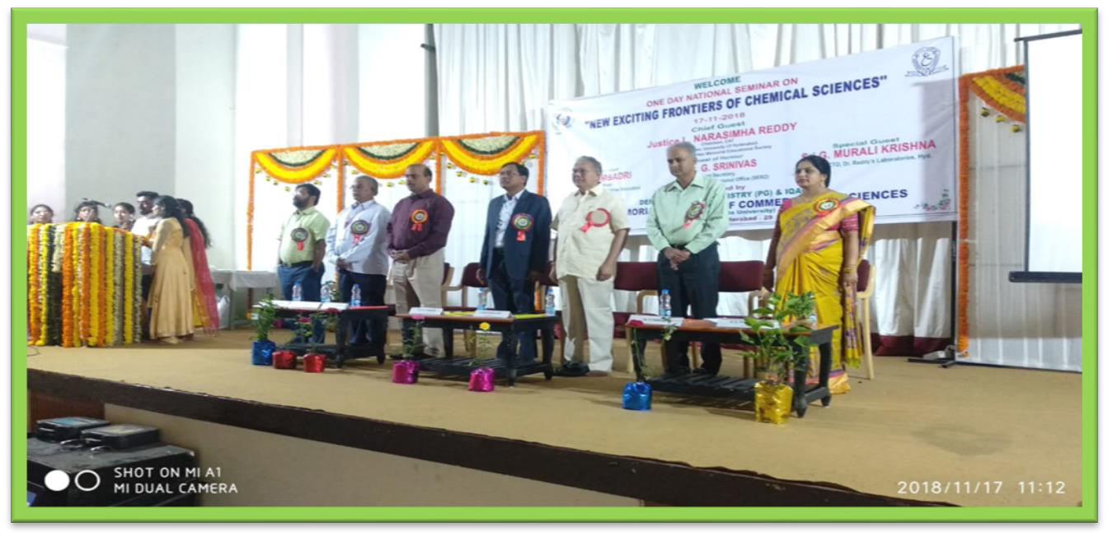
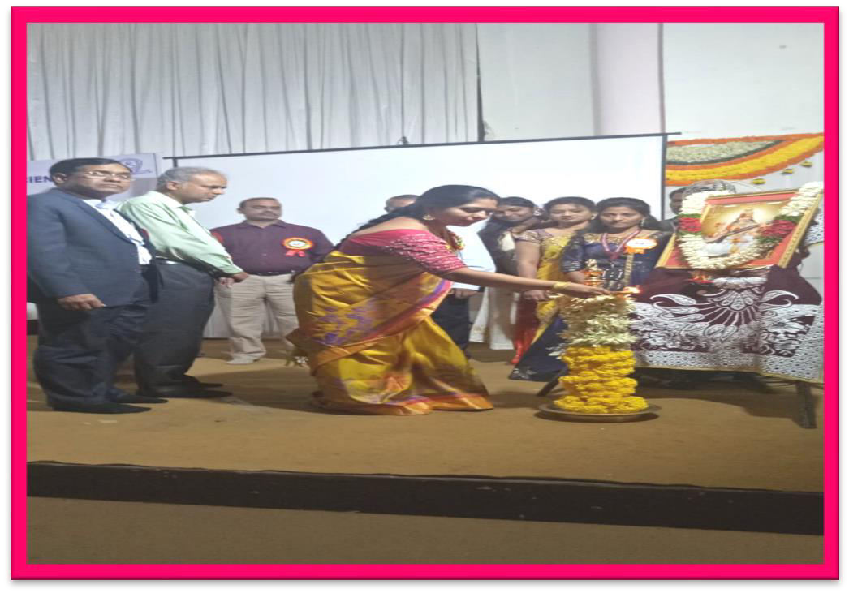

Lighting of the Lamp

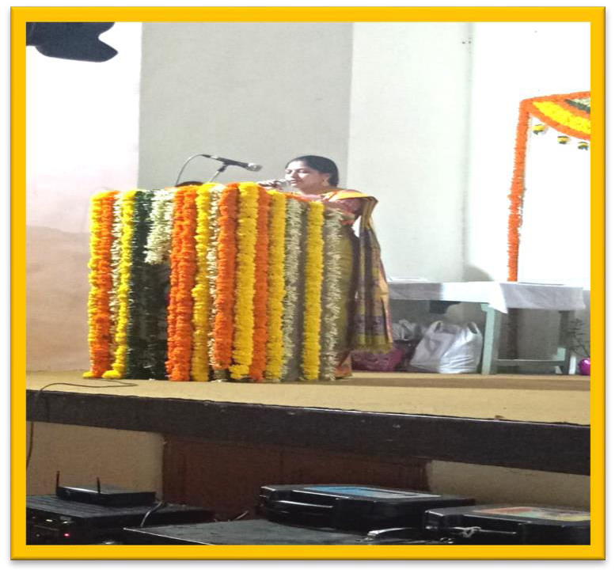

Mrs. P. Sharavanthi HOD presenting National Seminar report
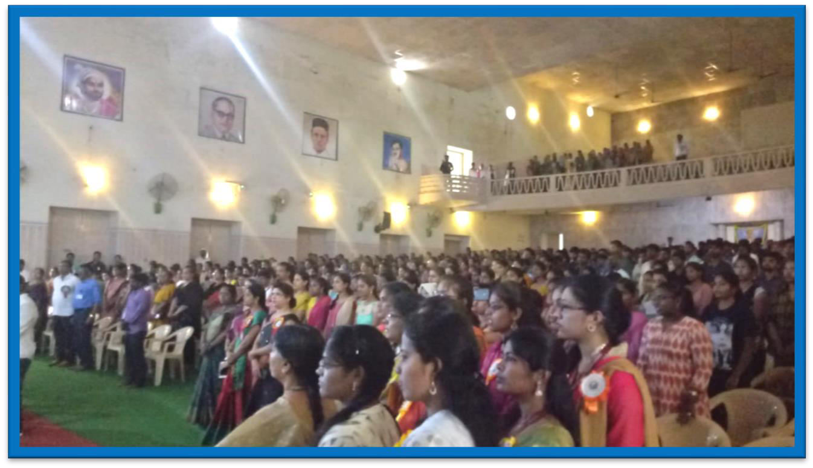
Students and Faculty from various colleges gathered in large number in the Auditorium for attending National Seminar

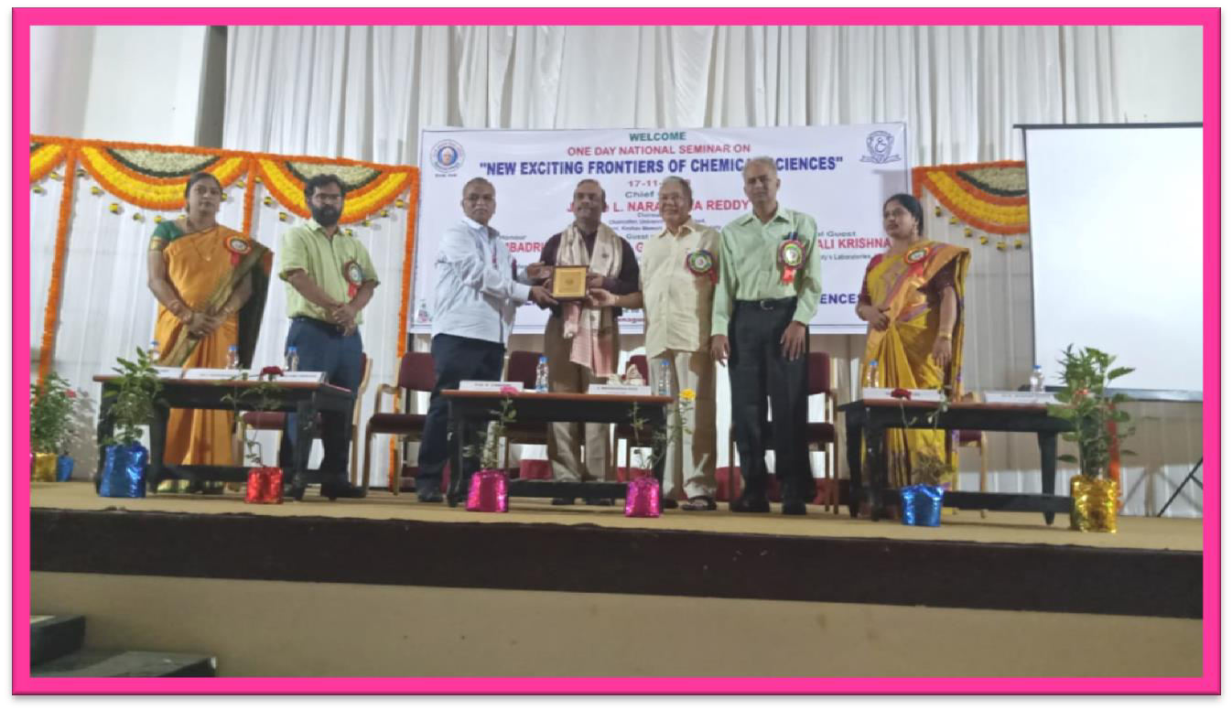

Felicitating the Special Guest Dr.Murali Krishna from Dr Reddy’ laboratories
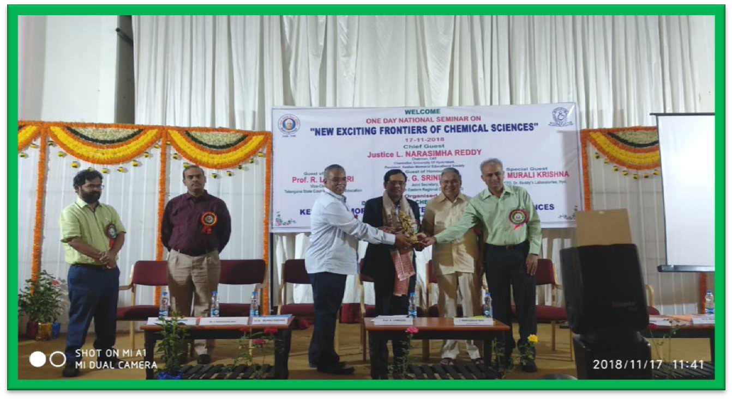
Felicitation to the Chief Guest Prof R.Limbadri Vice Chairman TSCHE

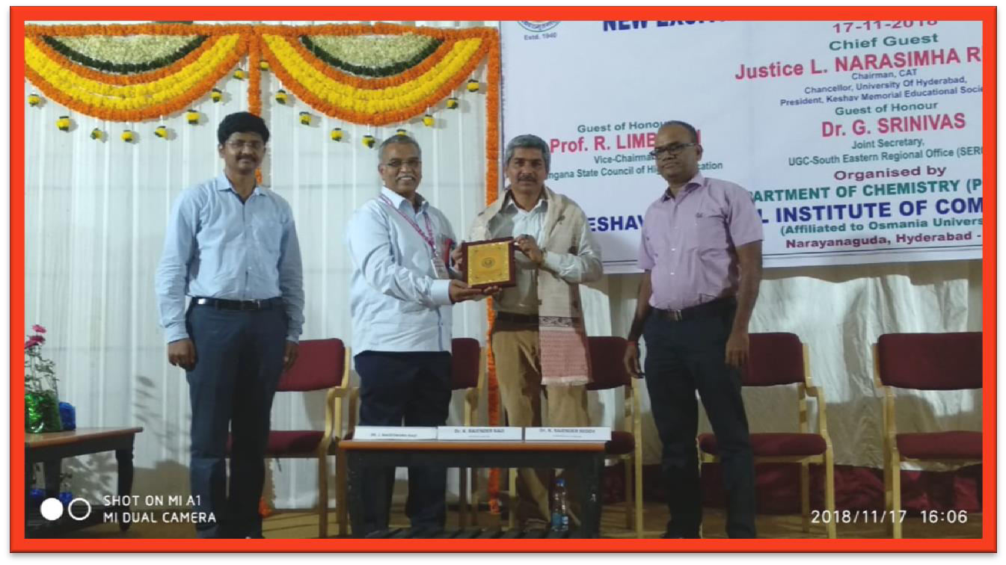

Felicitation to session Speaker DR.Rajendar RaoScientist NIN
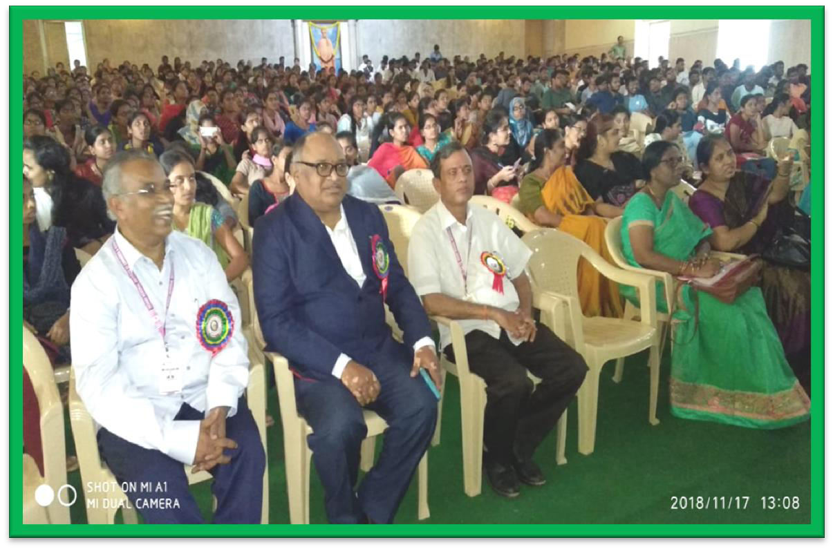
Guests, Faculty and Students In the seminar

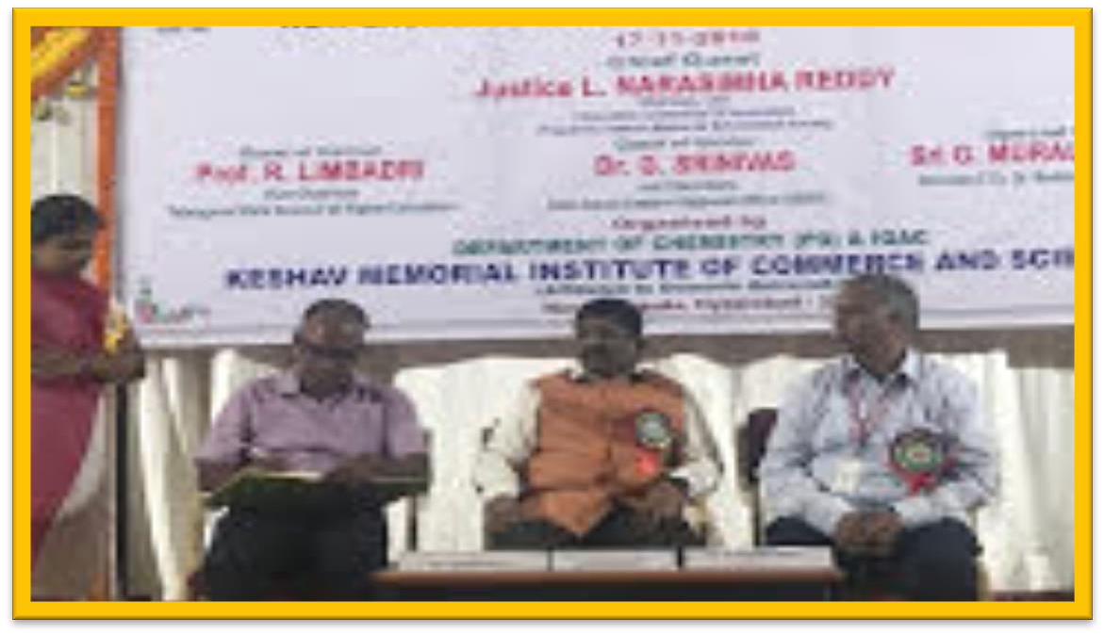

Prof. Shiva raj Dean UGC Affairs Dept of Chemistry OU at valedictory of National seminar
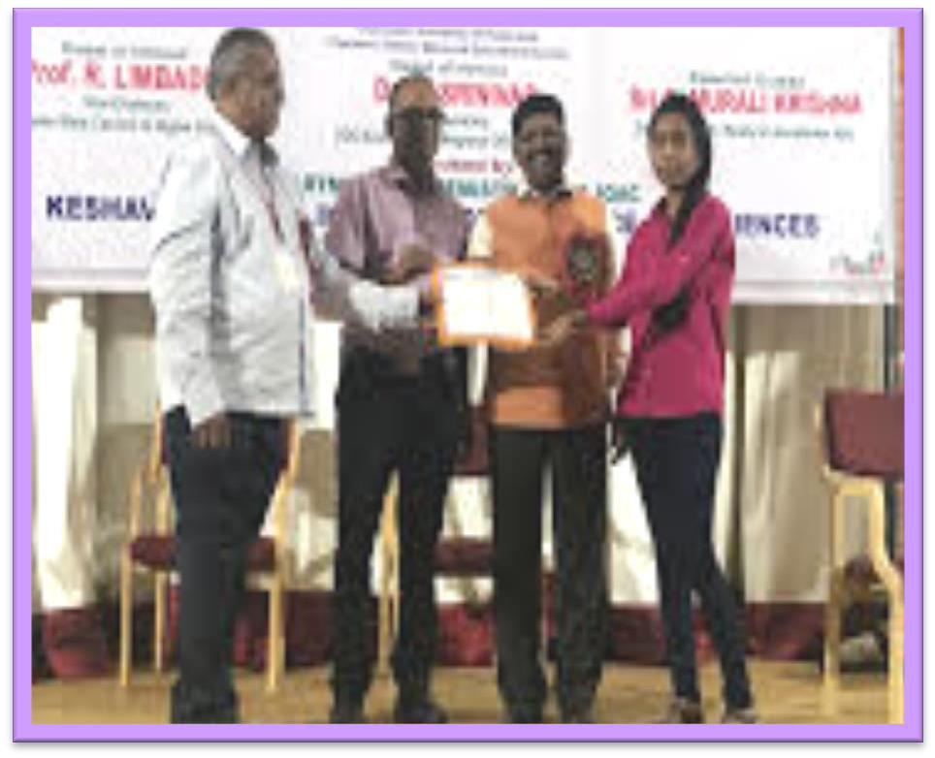
Presentation of certificates to the participants of National Seminar

ABOUT
One Day National Seminar was organized by Department of Chemistry P.G on 17th November 2018 on the topic “NEW EXCITING FRONTIERS OF CHEMICAL SCIENCES”. The seminar was attended by around 700 students and 45 faculties from 24 colleges. Four guest speakers were invited to present sessions. Session-I speaker was Prof .D.B. Ramachary from H.C.U, Session-II speaker was Prof. D. Ashok from O.U, Session-III speaker D .K. Rajender Rao scientist from NIN and session-IV speaker was Dr. Rajender Reddy scientist from IICT, Guest of Honor was Prof. R. Limbadri, Vice chairman, Telangana State Council of Higher Education. Dr. G. Srinivas, Joint Secretary, UGC SERO and special guest was Sri. G. Murali Krishna, Director CTO, HR at Reddy Labs, Hyd. All speakers have given very good interactive sessions to all the students. At the valedictory session Prof. Shiva Raj, Dean, UGC Affairs, O.U was the Guest of Honor.

OUTCOME:
The seminar was good, educative, interesting, and Informative. The interactions in the sessions helped the students to update their knowledge regarding various topics. The seminar has given a scope for extending collaborations with pharma industries and helped the students to know the latest trends going on in the field of Chemical Sciences. Through this seminar students acquired the skills and capabilities to withstand the prevailing competitions. It helped the students to update practical knowledge in pharma field. Students also learned the kind of knowledge and skills required to attain jobs in pharma industry.

