DEPARTMENT ACTIVITIES OF THE YEAR 2019

FIELD TRIP
Lab: Optimus Drugs pvt Ltd Lab Date: 23/02/2019 Place: Choutuppal

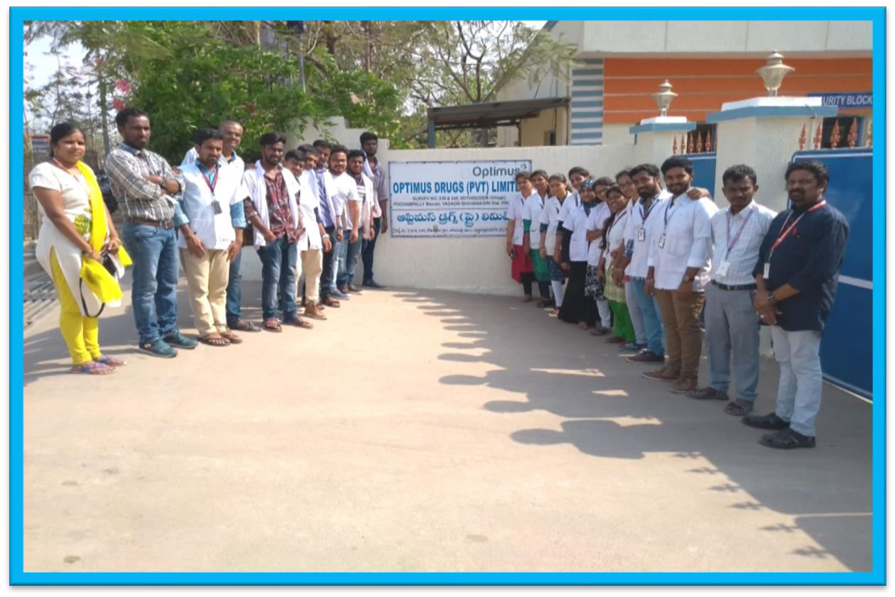
Department of Chemistry P.G (Organic & Analytical) planned for an Industrial Visit to Optimus Lab which is located at Choutuppal. All P.G Chemistry II Year students along with staff, lab assistants gathered in the college premises by 9:00 am & booked a bus to visit the lab.

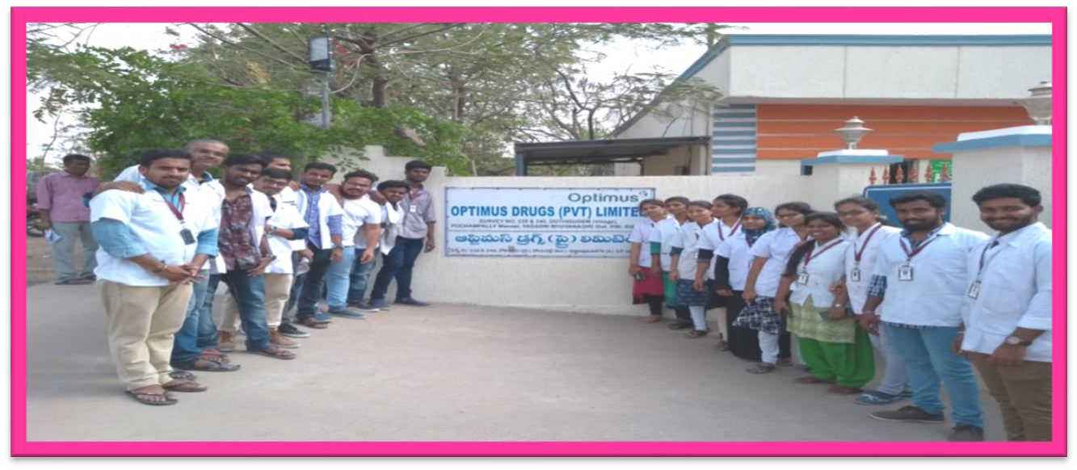

After reaching the lab Organic Chemistry students were taken to the production unit and Analytical Chemistry were taken to the Quality Control Department. There the students had the opportunity to see all the working instruments like HPLC, GC, ORD, UV, IR, TLC etc.
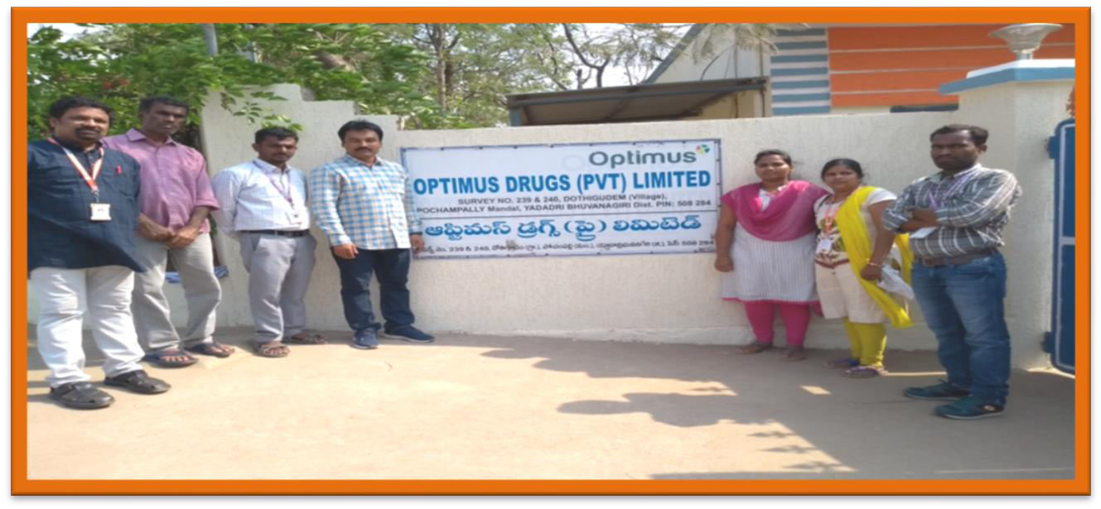

OUTCOME:

Students were benefited to see all the instruments & their working procedure right from the injection of the sample till the chromatogram was obtained.

Students have seen the complete process of chromatography live and the Quality Control lab patiently explained about the working and application of each and every instrument. Students were able to understand the entire process and chromatography live and the Quality Control staff of the lab patiently explained about the working and application of each and every instrument and gained more knowledge about every instrument and its working process. They also have shown the microbial analysis in water and total organic carbon in the sample.

There after they have to take the students to Quality Assurance Department where they have shown and explained about the manuals and documents which were prepared right from the receiving of the sample and obtaining its results. There after they were taken to the production department where they have shown the reactors and explained their working, sample preparation, conditions maintained for the instrument.

NATIONAL SCIENCE DAY CELEBRATION RESOURCE PERSON: DR. ROJA RANI PRINCIPAL, OUCW KOTI
DATE- 28/2/2019

Drawing, Painting, Best Out of waste, Healthy and Nutritious Food show and Poster presentation competitions conducted on account of National science day

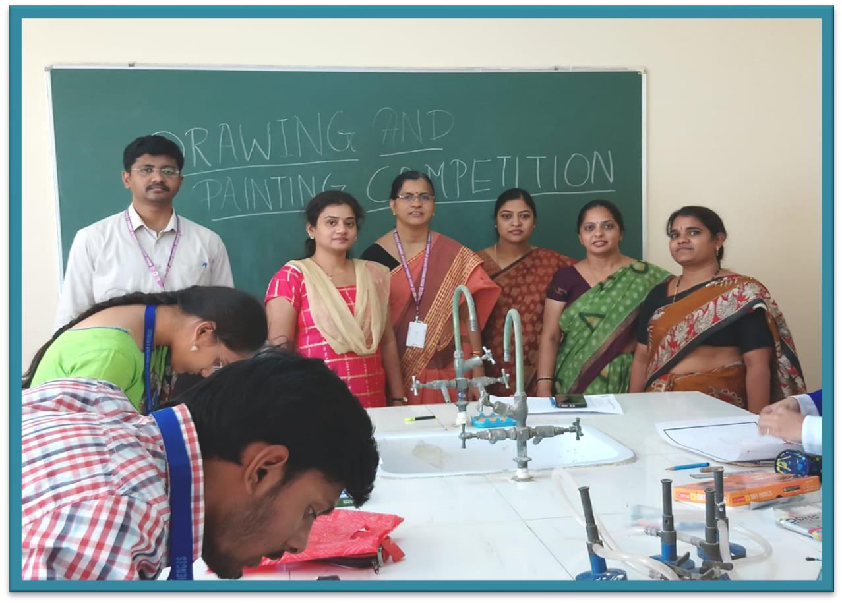
Students participating in drawing and painting competitions

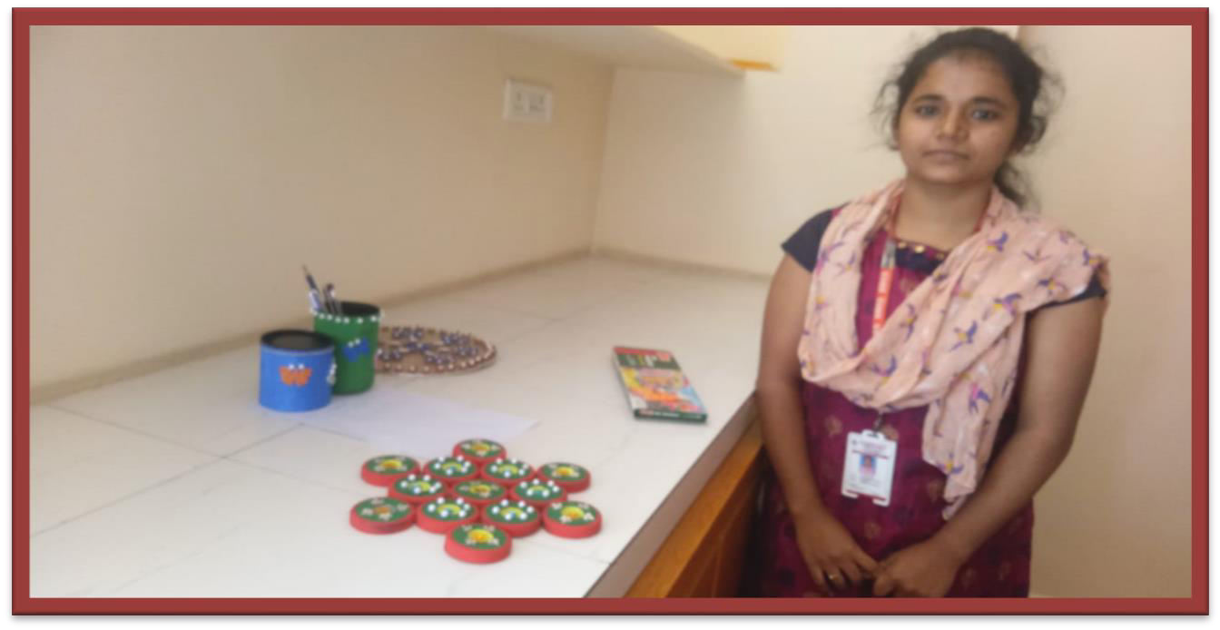

Best out of waste making

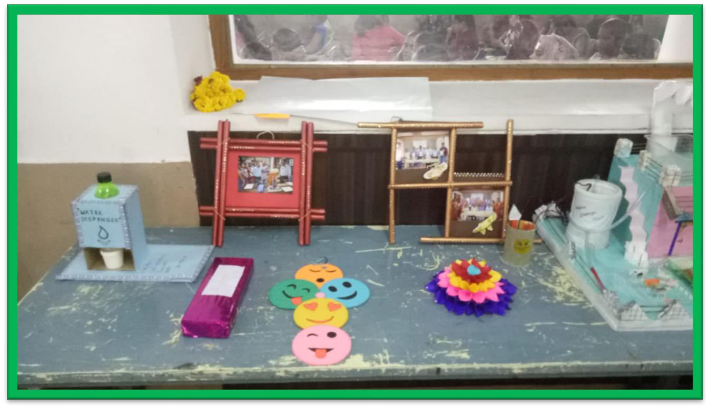

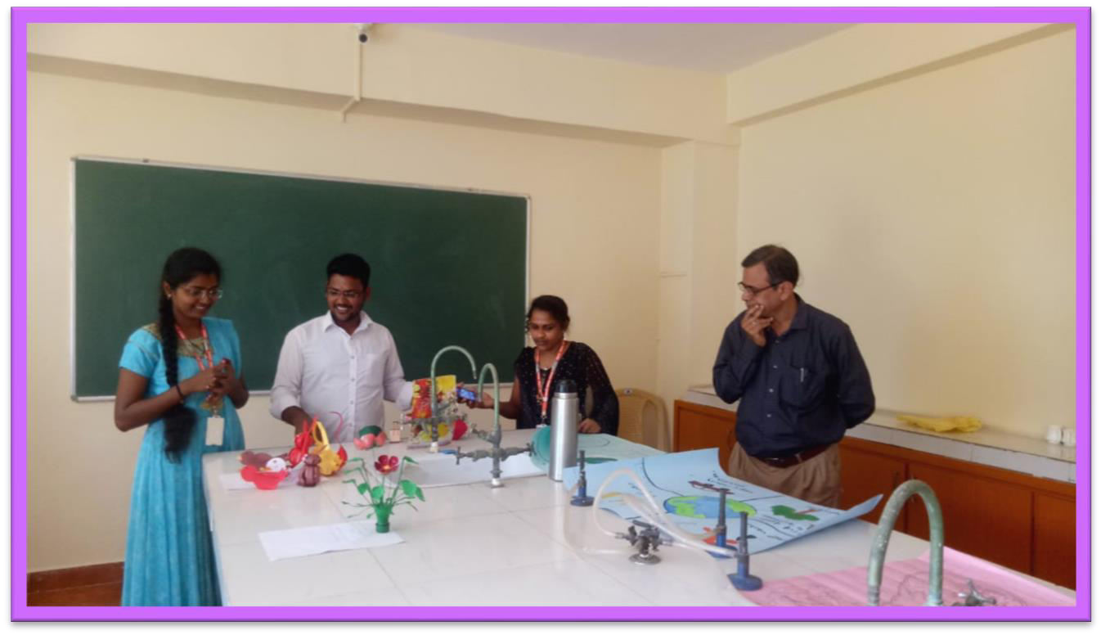
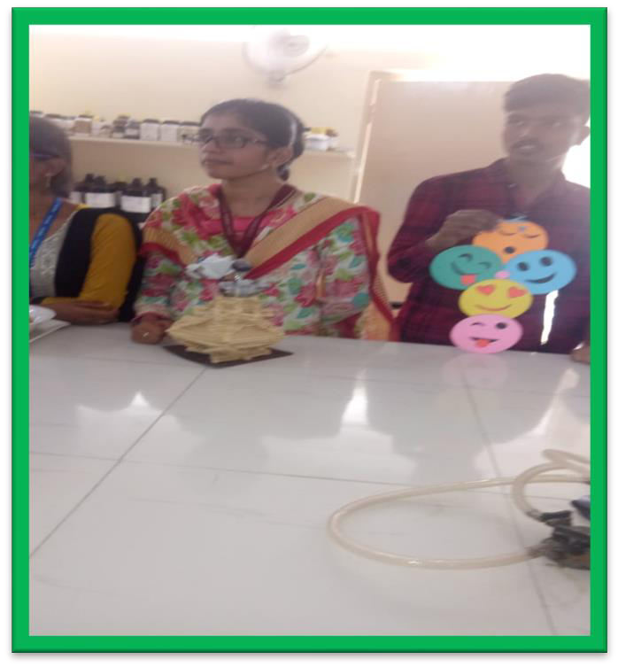

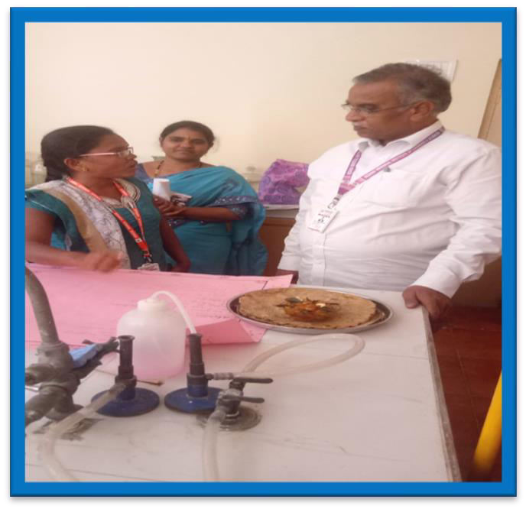

Healthy and nutritious food show by PG Chemistry students

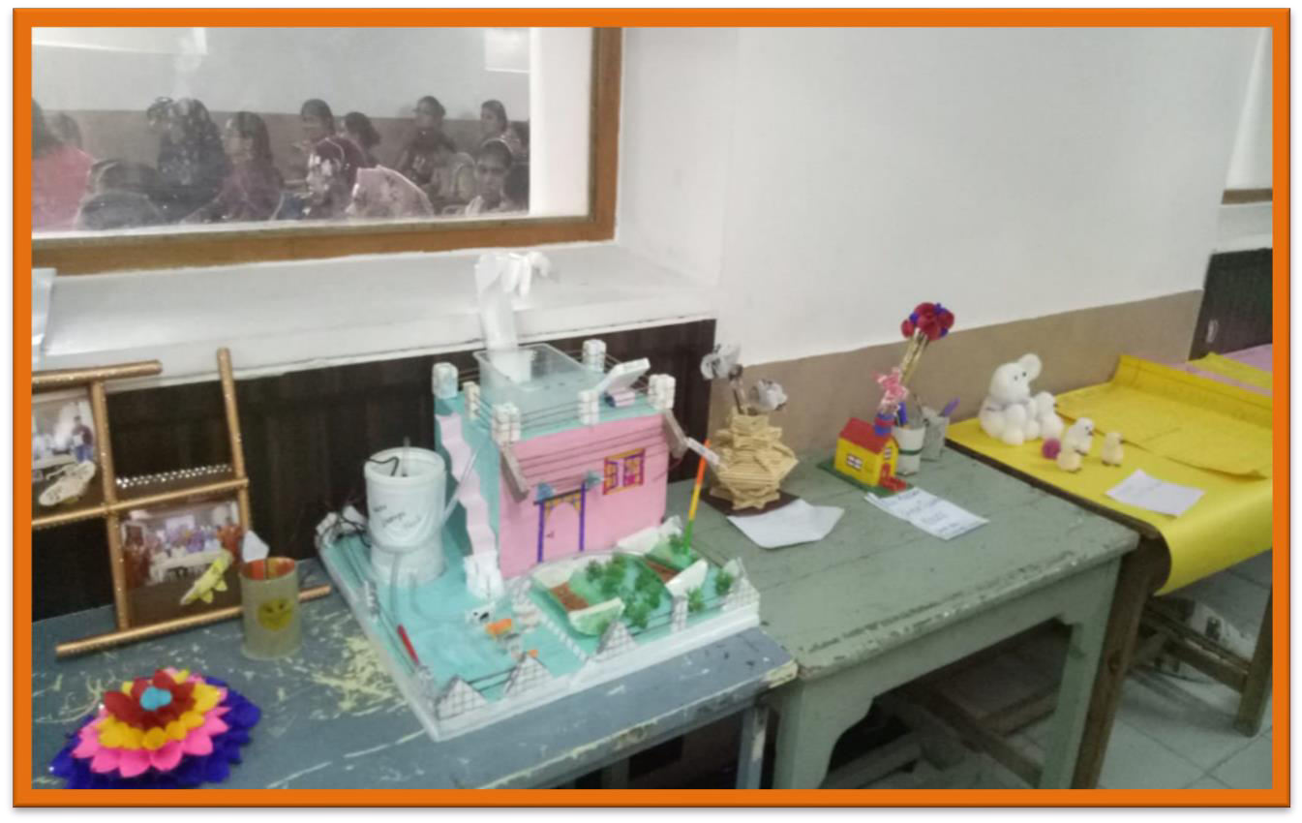
Model making from best out of waste

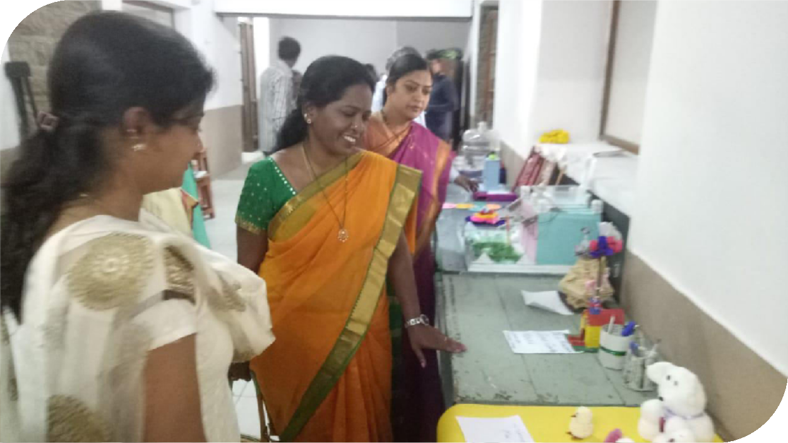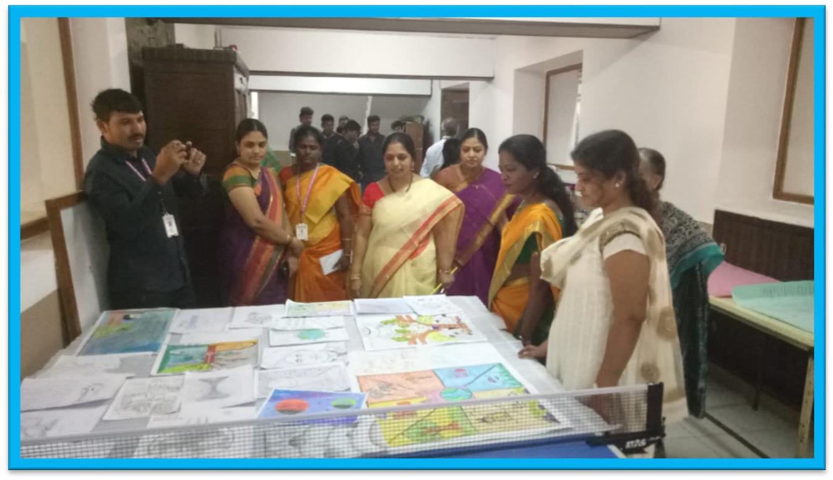

Drawing, Painting and Poster presentation by students

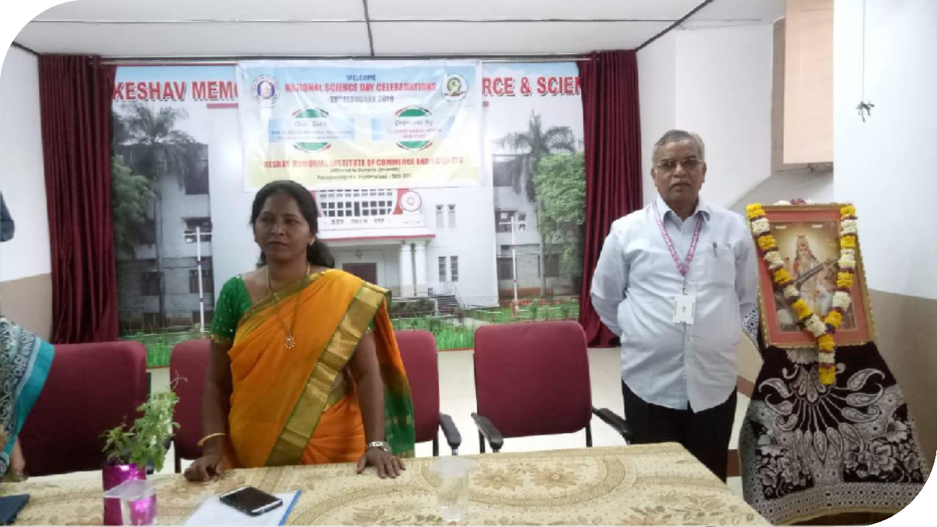

ABOUT:

Science Association Committee has organized few competitions to all science Dept students on account of National Science Day like Drawing, Painting, Best Out of waste, and Healthy and Nutritious Food show and Poster presentation.

OUTCOME:
Many students from different science Depts participated enthusiastically in various competitions organized by the science committee. The Guest speaker Prof.Roja Rani stressed about the importance of science in our daily life, and she encouraged students to take up research after their course completion.

GUEST LECTURE
Topic: ICP-OES
RESOURCE PERSON: Dr. B.R.V. Narasimhan principal scientist, NFTDC,

kanchanbagh, Hyd. DATE: 9TH NOV 2019
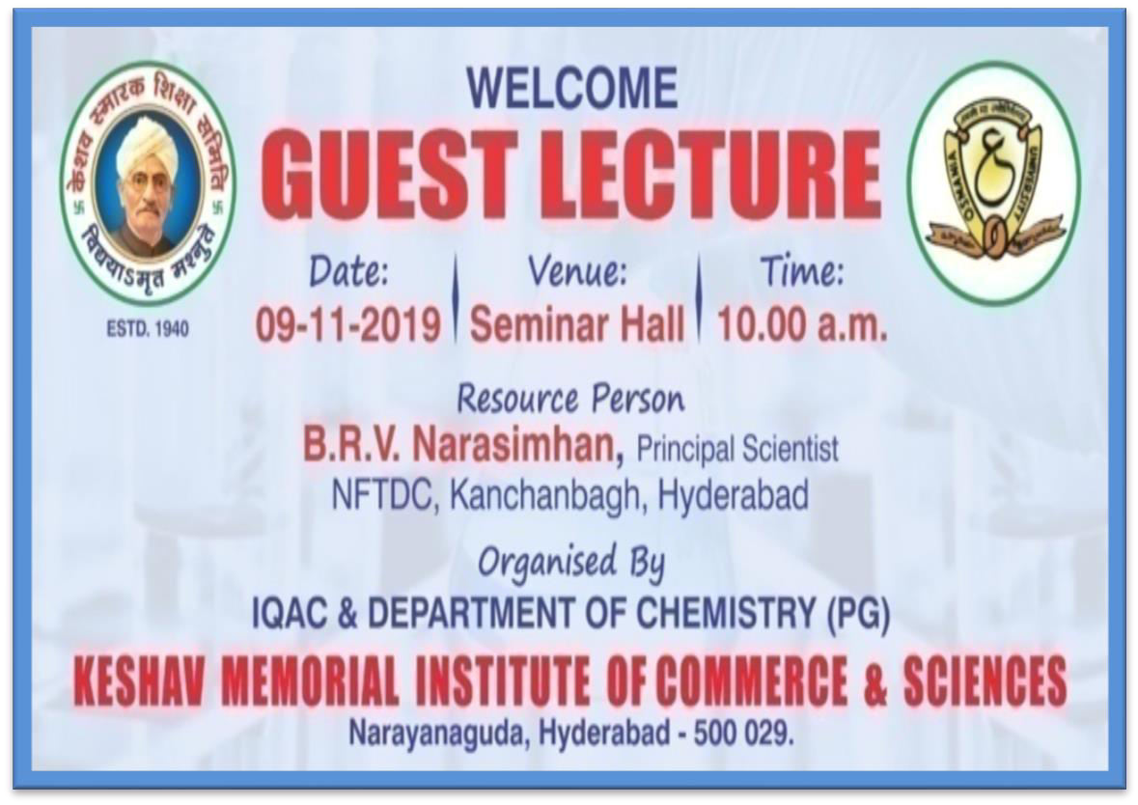
PG Chemistry Department organized guest lecture by resource person Dr. B.R.V. Narasimhan principal scientist, NFTDC, Kanchanbagh, Hyd, on the topic ICP-OES.

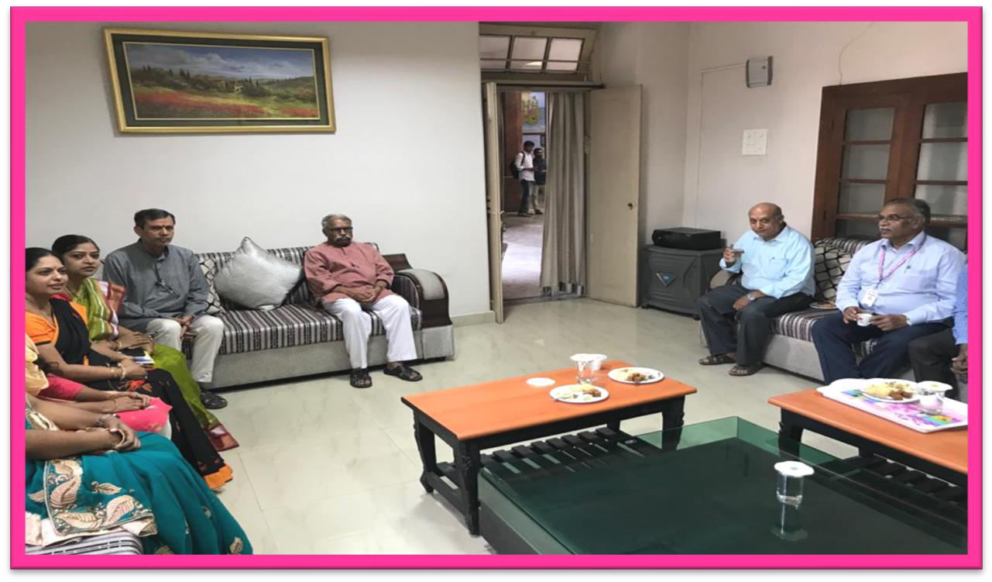
The guest interacted with the entire faculty
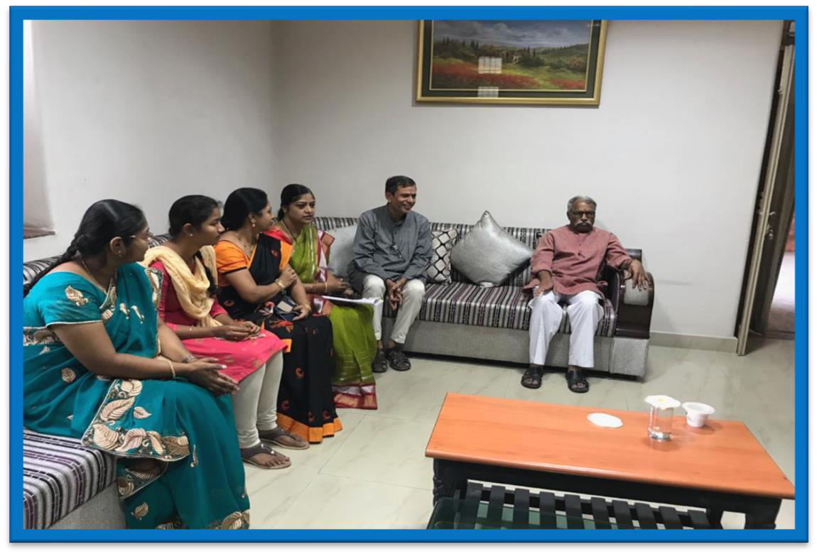
The entire faculty received the guest and welcomed him to the guest room. Secretary Dr.A.V.Subramaniam, principal and all chemistry Dept faculties greeted the guest and

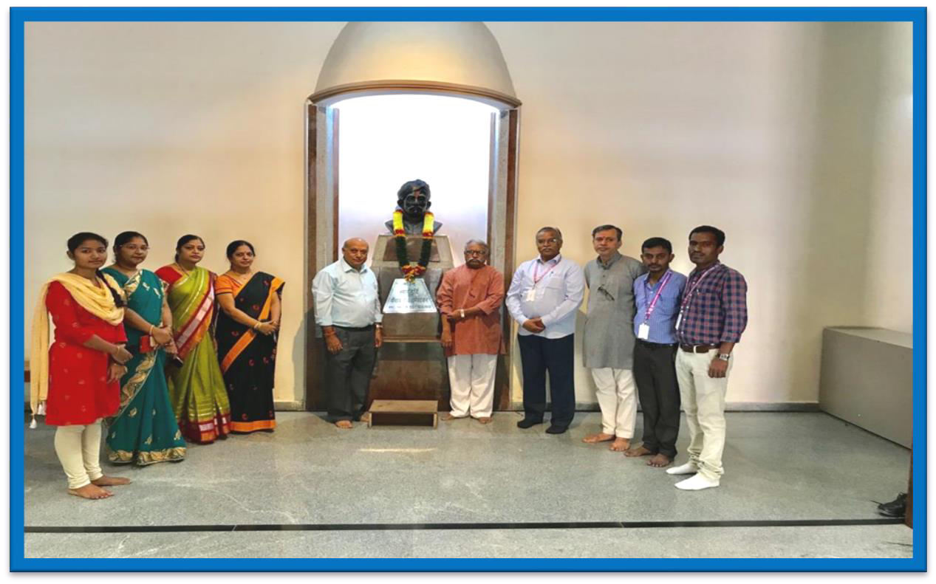
interacted with each other
Faculty along with the guest gathered at the statue of Keshav Rao Koratkar and honored him by garlanding.
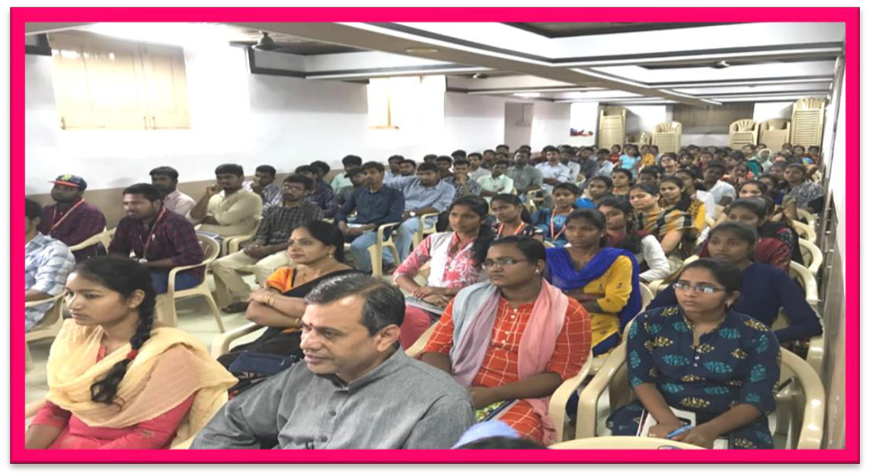
Students of PG chemistry gathered in SV hall for the Guest lecture.

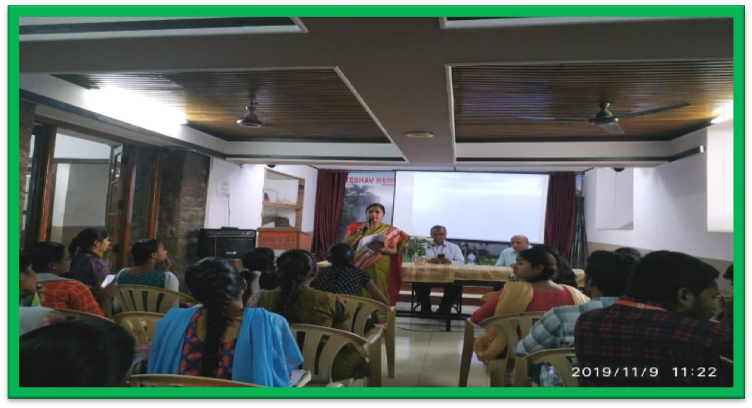
There after the entire faculty along the principal, secretary and guest speaker proceeded to SV hall for the lecture.

Mrs.M.Sangeetha Dept of Analytical Chemistry introducing the Guest Mrs. .M. Sangeetha Lawrence, Faculty in Analytical chemistry Dept hosted the
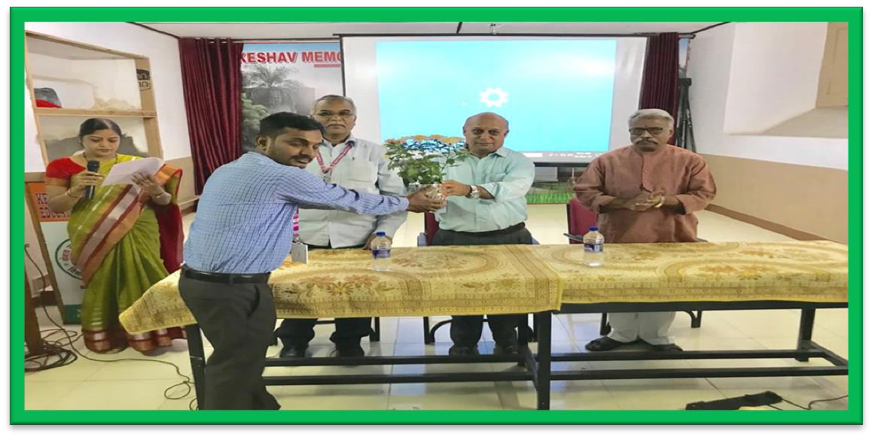
program.
The guest speaker, principal and secretary were invited on to the dais and the guest speaker was honored with a floral presentation by N. Krishna Prasad [faculty of organic chemistry dept].

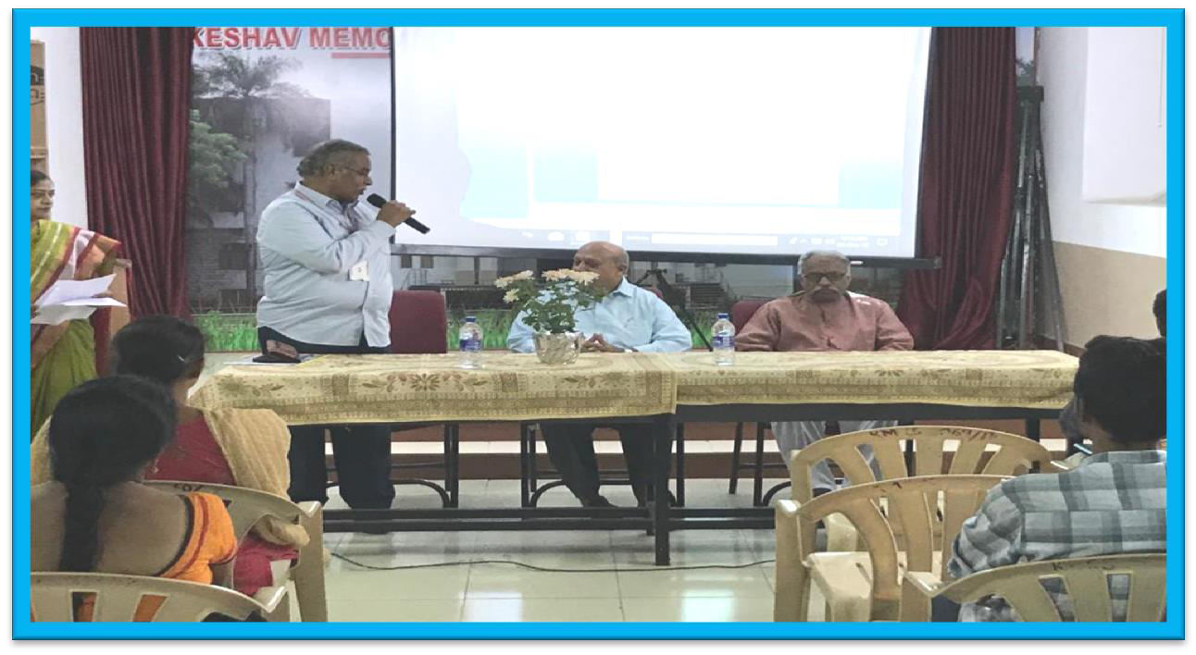

Principal addresses the gathering
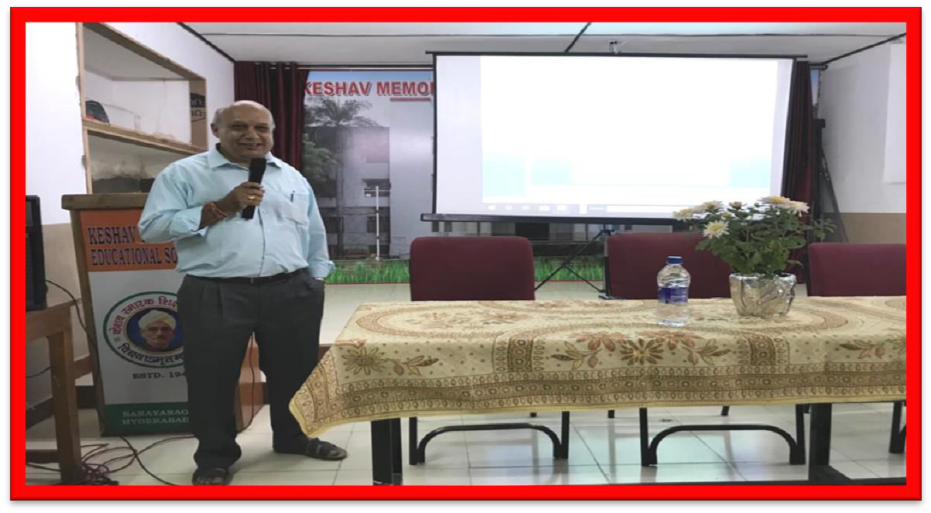
Guest speaker to continue the session

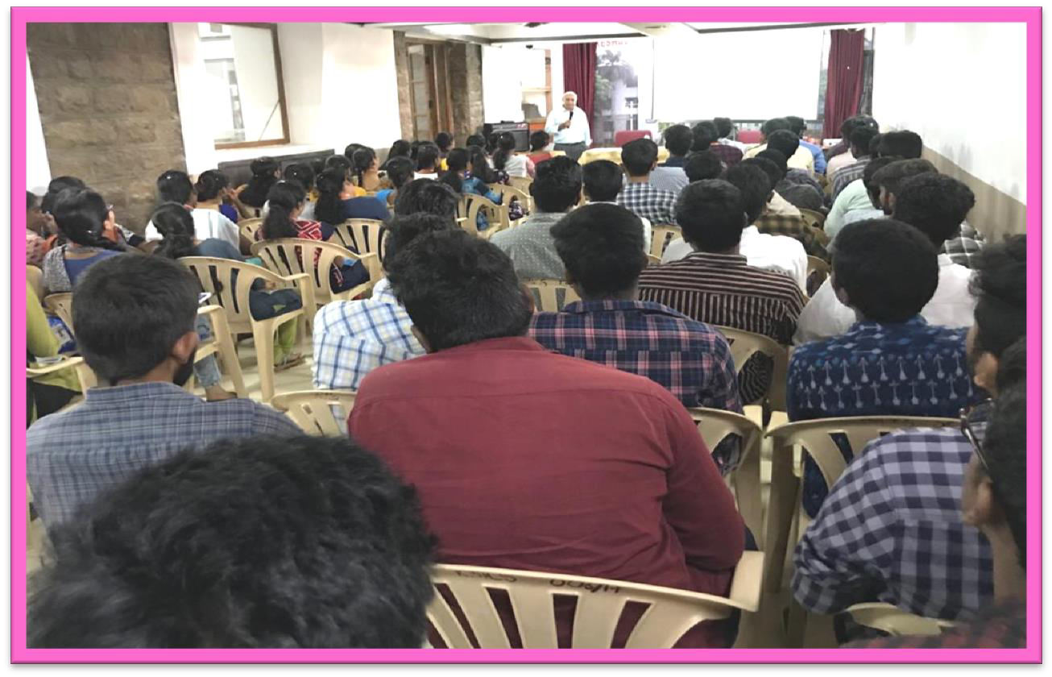

Guest speaker used PPT as a source to deliver his lecture
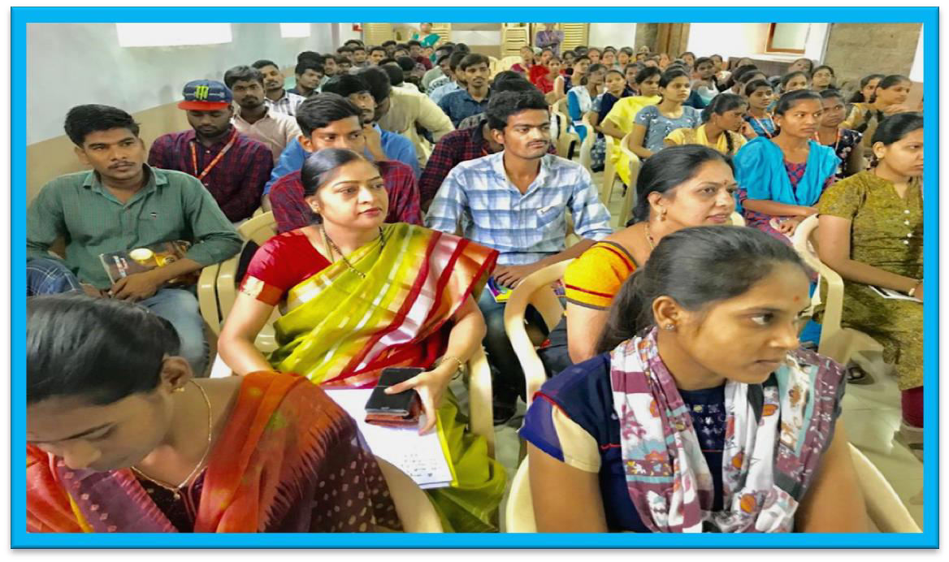

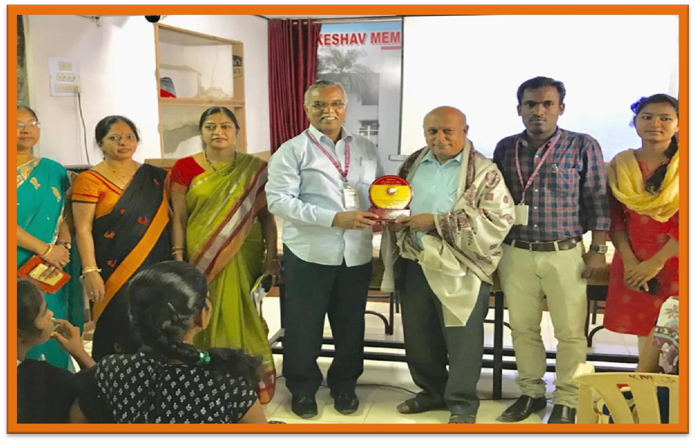

Guest was felicitated with a memento and shawl

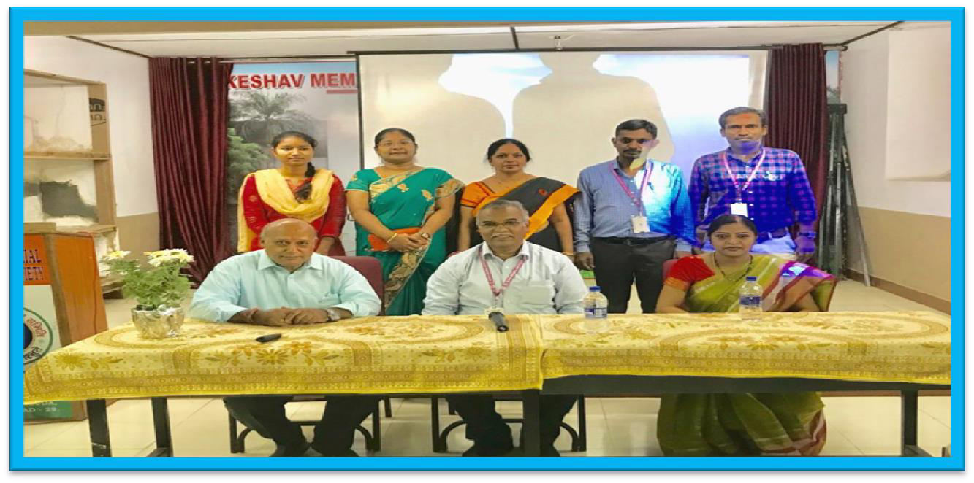

ABOUT

The lecture was very informative to all the students. The lecture was very good and interesting on the topic IPC-OES. Sir has said briefly about the atomic absorption, atomic emission spectroscopy, he stressed on the basics of absorption and emission spectroscopy and later on in detail explained about IPC-OES technique, its history, instrumentation, working principle, advantages, and its limitations. He has also shown the spectra and how to identify the elements in the spectra based on the emission line intensities and wavelength. He has explained about spectral identification which was very useful information to the students which helps them in their labs and interviews. Guest has asked the students to come out with questions or doubts on the topic so that, he would clarify them. Some students came forward with some doubts and the guest has clearly explained all their doubts.

OUTCOME:
Students clearly understood the basic concept of absorption and emission spectroscopy, instrumentation, principles, working, and how to identify spectra of various elements and their wavelength calculation. Students got clear idea about the identification of most intensity line in the spectrum and wave length identification

INDUCTION PROGRAMME

RESOURCR PERSONS:
Sri. D. Ramakrishna IAS, IG, Registration and Stamps and Special Guest Prof. Battu Satyanarayana O.U. DATE: 18-11-19

All the Departments of PG organized Induction programme on 18.11.19 at Sardar Patel auditorium for all the newly admitted students of all PG courses.

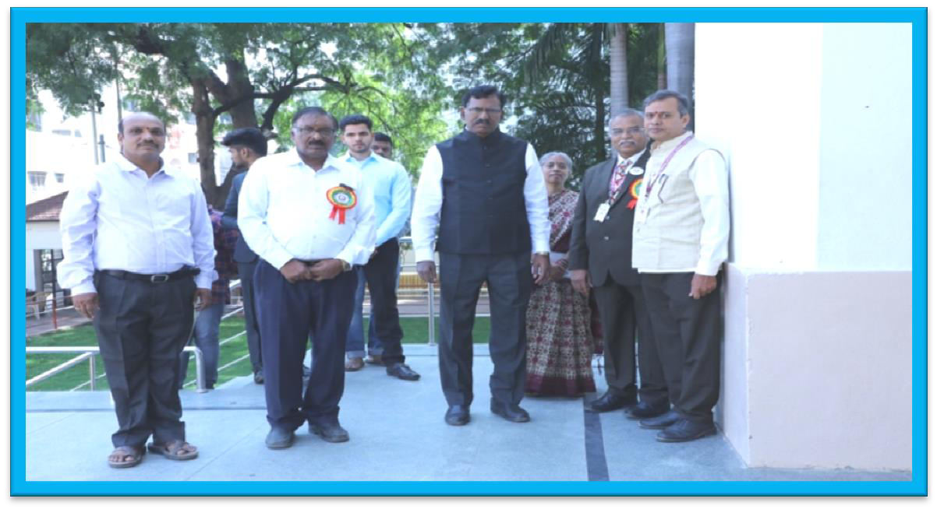
The Guests arrived into the college premises by 10:00am.They were received by secretary of KMES Dr. A. V. Subrahmanyam, of KMES Sri. L Prabhakar Reddy, Principal Dr. Nageswara Rao, and faculty members of KMICS.

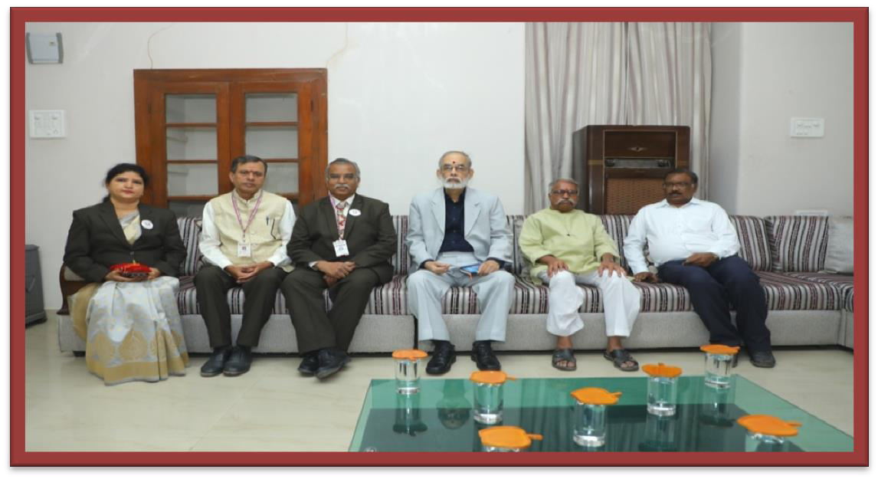

They were invited to The Guests Room. The chief Guest was Sri. D. Ramakrishna IAS, IG, Registration and Stamps and Special Guest Prof. Battu Satyanarayana
O.U. Management Principal and faculty interacted with them and offered good Hospitality.
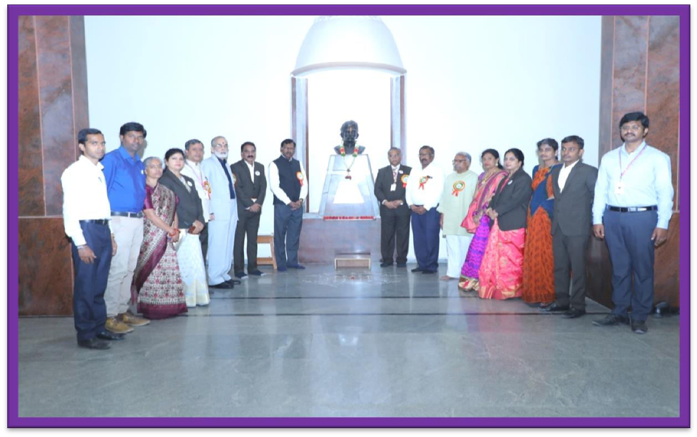

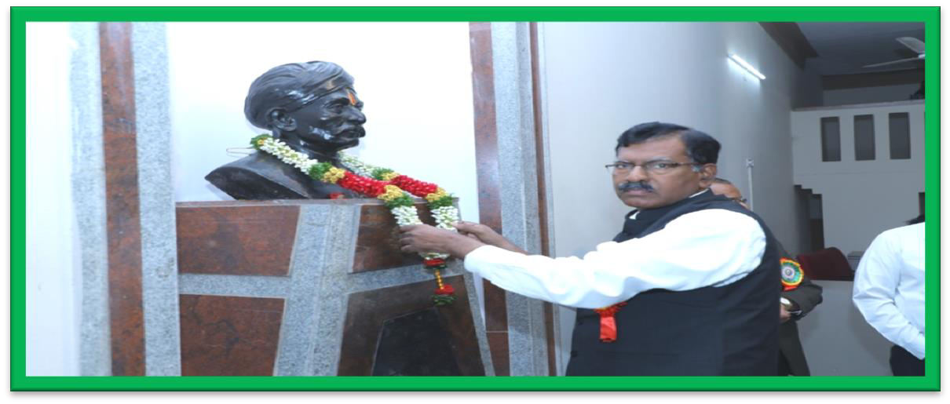

Later on all of them along with The Chief Guest and Special Guest marched towards Keshav Rao Koratkar statue and honored the statue with garland.
Mean while all the Departmental activities, Labs and achievements were focused to all the newly admitted students and their parents gathered in sardar patel hall, the departments have arranged a slide show, so that the newly admitted students and parents get to know the insights of each department.
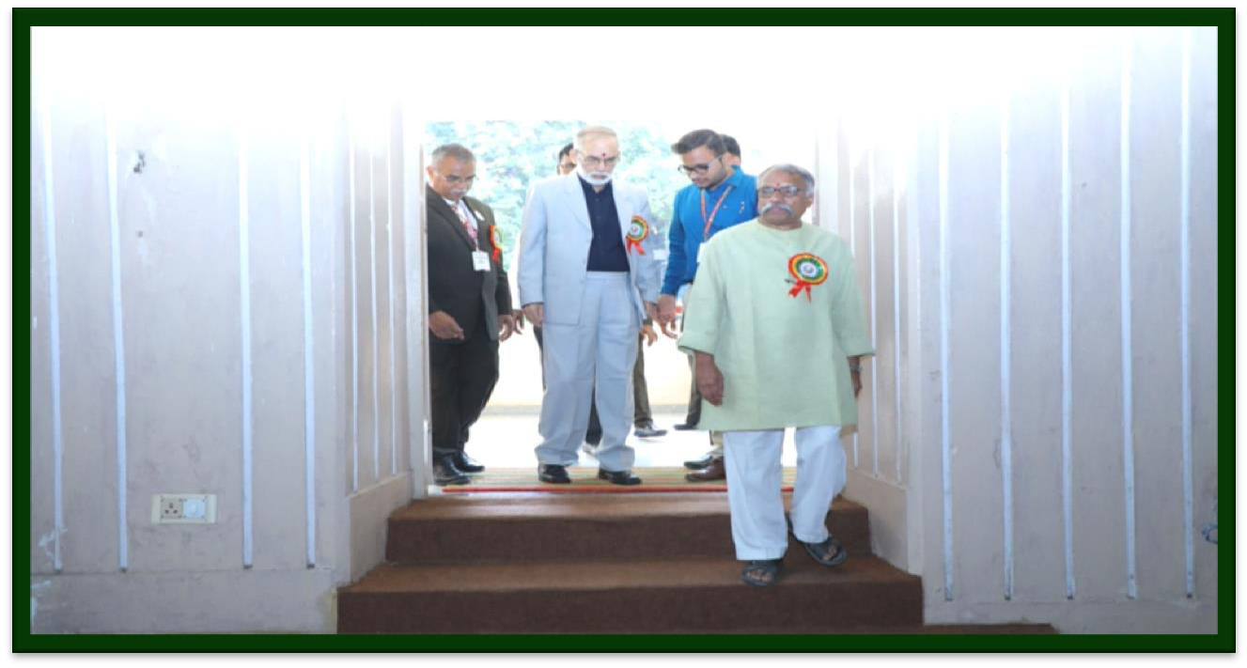
After honoring Koratkar statue all the Guests, Management, Principal and faculty proceeded towards sardar patel auditorium where the programme arrangements were made.

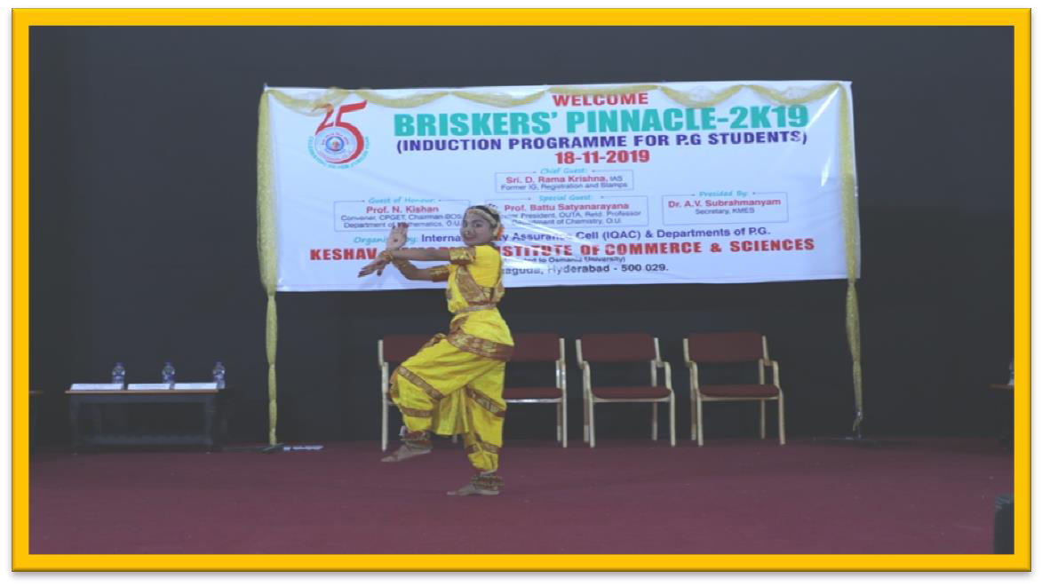

The official progaramme started with a welcome classical dance performance by V.Geetha of Msc. Analytical chemistry Ist year. The guests and all the students appreciated the delightful performance.
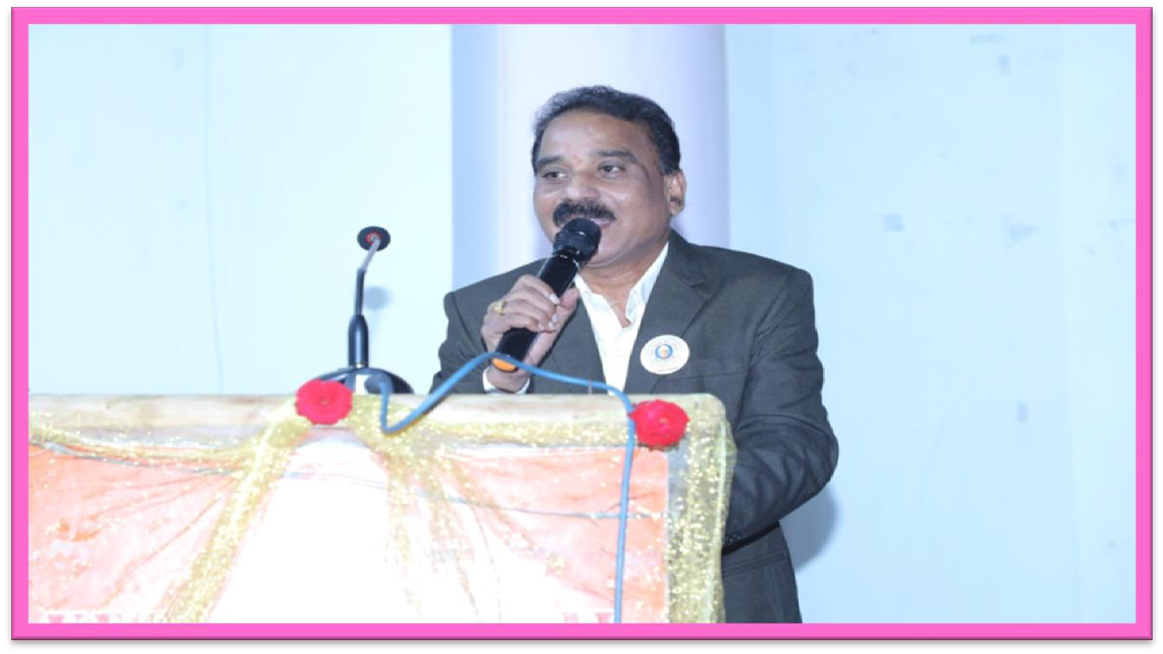
Welcome Note and Introduction about college was given by N. Tammi Reddy NACC Coordinator.

REPORT:
The programme was hosted by the students. The Guests, Management and principal were invited on to the Dias and honored by presenting blossom flower plant saplings. Every new beginning starts with traditional lamp lighting ceremony to goddess of knowledge saraswathi. The entire Guest, management performed the lighting of the lamp along with an Instrumental note of prayer song being played as the background music.
Then everyone in the hall rose to their feet for Vandemataram prayer song. Students gave the Introduction of The Chief Guest and special Guests.
All the five Department Heads gave a brief report about Their Departmental activities and achievements. All the Department Heads said that they world organize seminars, extension lectures and Guest lectures, field trips, many cultural and extracurricular activities to excel students in their academics and Non-academic areas. They said that many students secured O.U. Top 10 Ranks and passed with good percentage Result. Many students are well placed and having good settlement. There after students from all courses gave the feedback about the college and activities.
The principal of KMICS Dr. J. Nageswara Rao addressed the gathering. He said that the success is brought by the students. Secretary of KMES Dr A. V. Subrahmanyam garu presented a motivational speech.
The special Guest Prof. Battu Satyanarayana has given an Inspirational speech. He said that students should get into research field, clear NET and SET exams and acquire higher Qualifications. He said discipline and punctuality and

75% Attendance are must for a student to have success in their educational carrier Special Guest appreciated the discipline of students of KMICS. He said to Aim for high goals.
Sri. D. Ramakrishna garu, IAS has given an elaborate speech. He said that preaching and teaching are noble professions. He said that PG course is like a bridge between UG and Research scholars. He said that without observation there is no inference which is common in both commerce and chemistry. He appreciated the principal, because some are scary but he is caring.
All the Departments have conducted some activities for students like JAM Session, Quiz, Group Discussions, Tambola Game, Best out of waste, Poster presentation, Healthy and Nutritive food display. The winners of the above programmes were given prizes and prize distribution was done by the Chief Guest, Special Guest and secretary of KMES. The Guests were felicitation by secretary and joint secretary of KMES with a shawl and memento as a token of love and appreciation.
Vote of thanks was proposed by N. Uma Devi IQAC coordinator.

Later on the cultural program began all Department students participated in various cultural programs like Dances, Medleys, Instrumental, Skits, Folk dance, Bhangda Dance on national integration etc. All the students have relished their performances. The programme conducted on note of National Anthem followed by sumptuous lunch for all provided by the Management.

GUEST LECTURE
TOPIC: FUNDAMENTALS OF SPECTROSCOPY DATE: 20-12-2019
RESOURCE PERSON:DR.A.KRISHNAM RAJU,DEPT OF CHEMISTRY,NIZAM COLLEGE
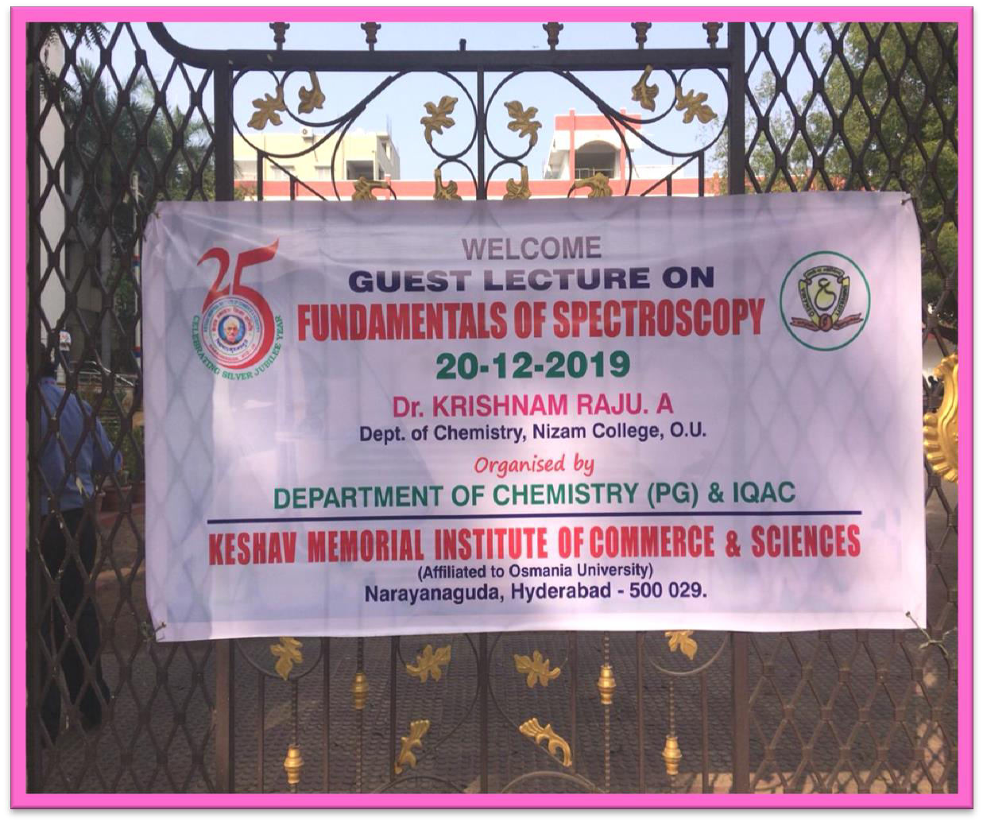

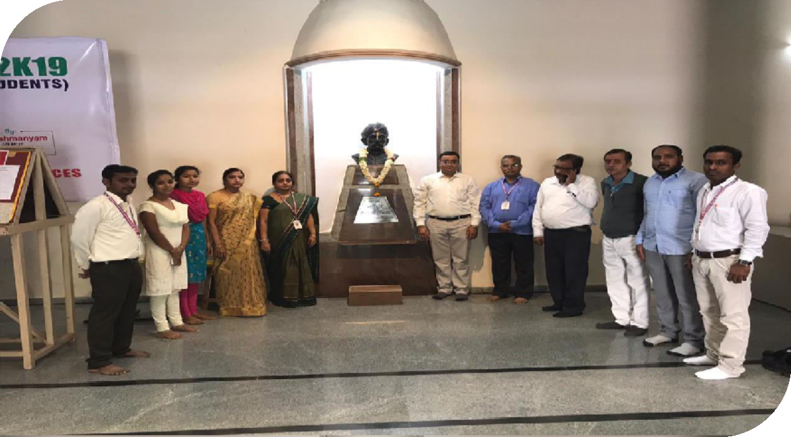
Guest speaker, principal,vice principal,and all PG chemistry Department faculty gathered at Keshav Rao Koratkar statue and honored with a Garland.
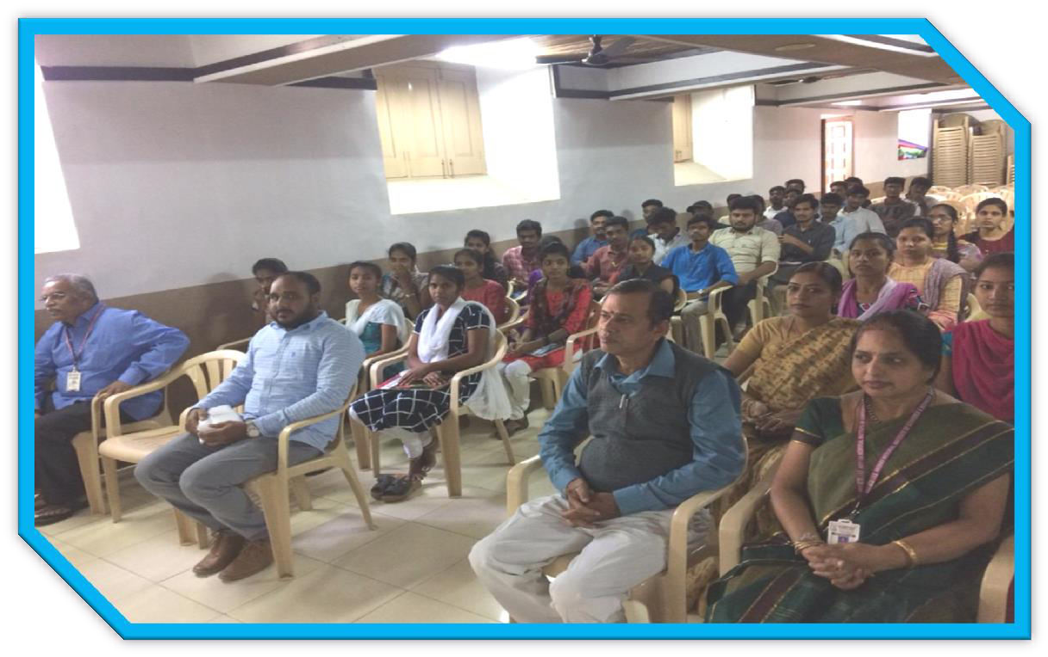
All students and staff gathered at S.V Hall for the Guest Lecture

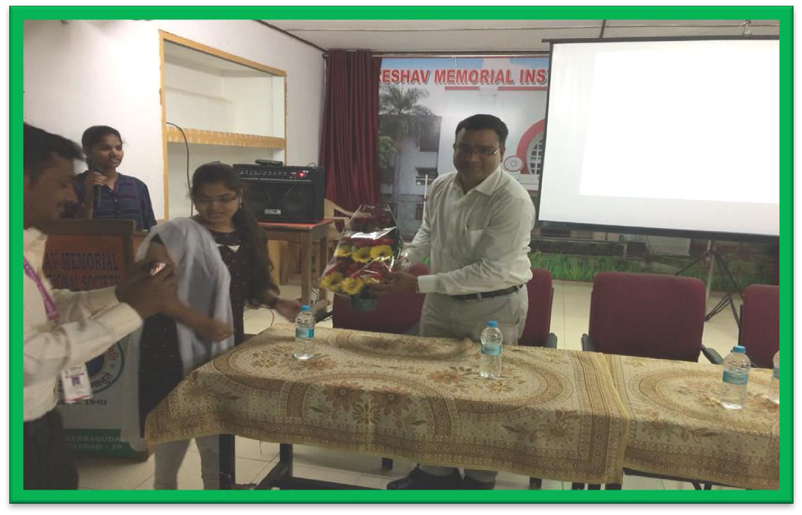

Guest was honored with a floral sapling presentation
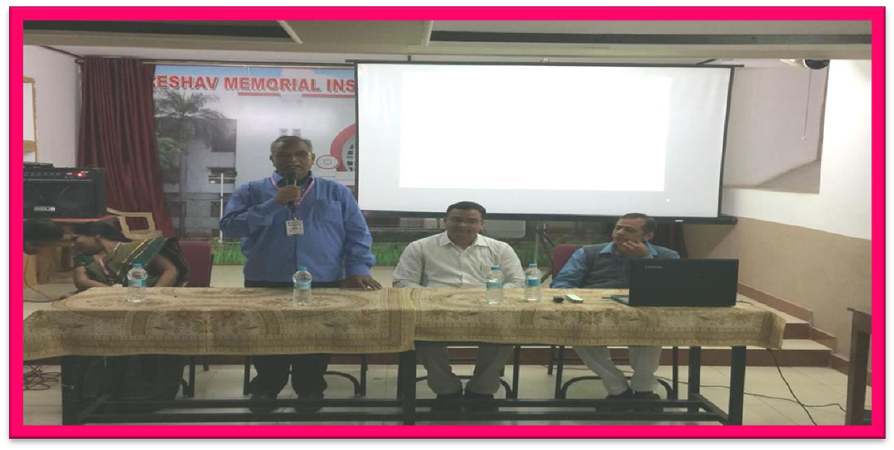
Principal addressed the gathering

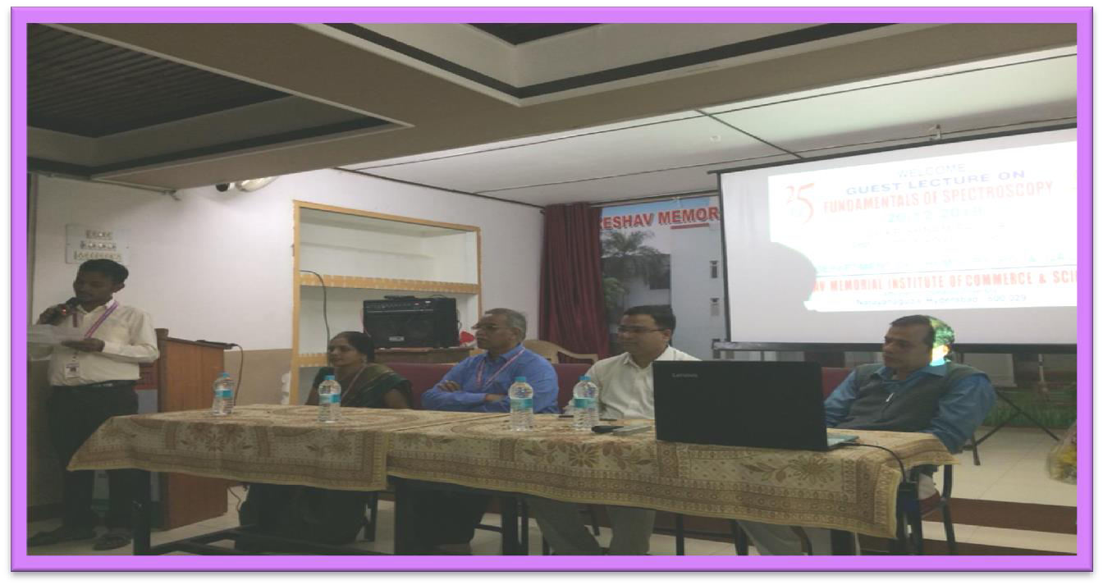

Guest speaker introduction was given by faculty N. Krishna Prasad
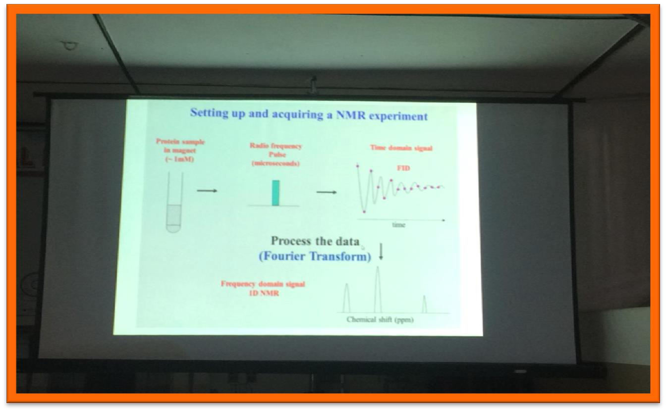
Guest speaker used PPT mode to deliver his Lecture

About the lecture:
Guest speaker explained about the Fundamentals of Spectroscopy. In his lecture, he clearly explained about the instrumentation, principle of NMR spectroscopy, he also explained the chemical shifts, factors effecting chemical shifts, isotropic and anisotropic effects, precision of molecules, gyro magnetic ratio; he has quoted many examples to explain precision and chemical shifts of different molecules under different chemical environments. He has demonstrated Gyroscope to explain precision of molecules. He cleared many doubts of the students by interacting with them.

Outcome:

All the students understood very clearly about the topic fundamentals of spectroscopy, after the lecture students were having clear idea regarding chemical shifts, factors effecting chemical shifts, isotropic and anisotropic effects, they clearly understood what is precision by seeing the demonstration of Gyroscope instrument, and students were having clear understanding regarding the principles of NMR spectroscopy.

